A77- 4G-replaceable battery-Zhanrui 2.8 standard
Product Specification (Model: A77-4G-可更换电池-展锐2.8标准)
Product Information
Appearance Name | A77 4G Law Enforcement Instrument
Series Model | A77-4G-可更换电池-展锐2.8标准
Features | Domestic chips,  Dual-frequency Beidou  IP68 two-color mold  (Can support Hongmeng)
Six Views
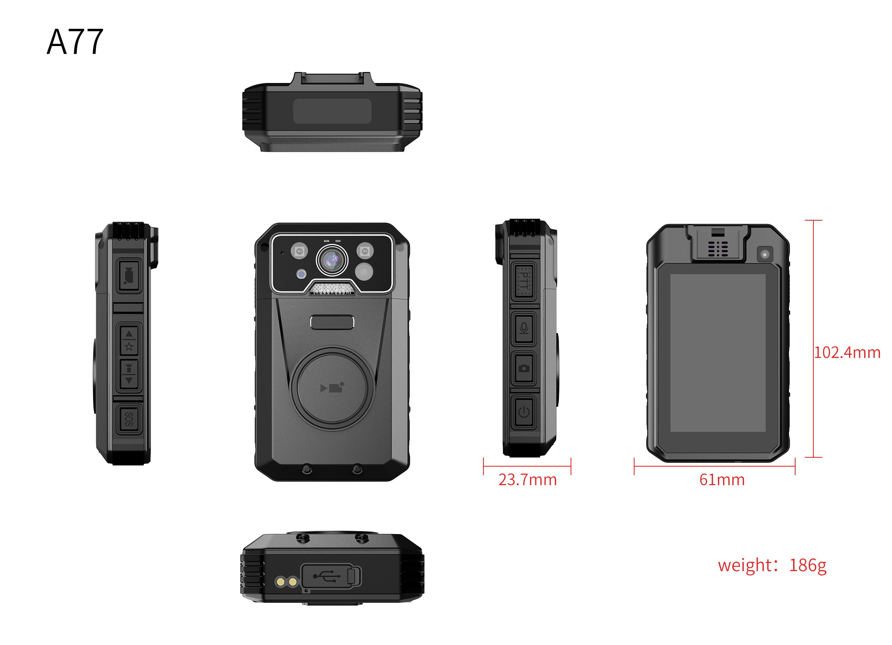
Basic Information
processor | Zhan Rui 7863 2*A75@2.0G+6*A55@1.8G
operating system | Android 12
Screen size | 3.1 Inch multi-touch screen 480*800
Default battery capacity | 3500mAh
Optional battery capacity upgrade | no
charging duration | 3 hours
Continuous recording duration | about 9 hours
standby time | >300 hours without APP, depending on APP
anti-shake | no
image format | MP4
compression format | H.264/H.265
Video size | Maximum 2K(2560*1440)30FPS
photo format | JPEG
horn | 2W
body memory | Standard 2+ 32G, expandable up to 512G
Rear camera (auxiliary AF) | Default is not optional 1200W
Front camera (screen) | Default is not optional 200W
Rear camera (main) | 400W
Photo size | Maximum 58 million
noise reduction module | optional
Lighting
laser lamp | no
alarm lamp | no
infrared lamp | have
white light Lamp | have
Interfaces
USB interface | USB 2.0
charging interface | Type-C
headphone jack | Type-C
G-sensor | support
vibration motor | support
external camera | support
charging base | support
charging method | Complete machine (detachable battery)+ seat charger
charger | 5V-2A
Data Functions
Sim/TF Card Slot | Single Sim Single TF
WIFI | WIFI5.8 a/b/g/n/ac
Bluetooth/433 | BT5.0(BR/EDR + BLE) supports Bluetooth remote control, Bluetooth voice, Bluetooth tag positioning, etc.
positioning | Dual-frequency Beidou
compass | support
air pressure sensor | support
temperature sensor | support
ambient light sensor | support
NFC | Support options
encryption card | support
Dimensions
Length (mm) | 61
Height (mm) | 102.4
Thickness (mm) | 23.7
Weight (g) Approx | 186
Other Network Functions
network standard | Global frequency band  2G:GSM(B2/3/5/8)  3G:WCDMA(B1/2/5/8)  4G:  TDD(38/39/40/41)  FDD(B1/2/3/4/5/7/8/20/28AB)  2G:GSM(B2/3/5/8)  3G:WCDMA(B1/2/5/8)
video intercom | Support law enforcement instrument to platform single and two-way video intercom, support law enforcement instrument end-to-end single and two-way video intercom (requires integration of third-party software SDK)
Voice cluster intercom | Support group intercom, end-to-end intercom
voice broadcast | Support TTS voice broadcast
voice control | Currently, it can only support Chinese, and other languages need to integrate third-party speech algorithms or secondary development
Facial and license plate recognition | support
Platform Administration software | Support real-time preview/real-time positioning/trajectory playback/intercom/monitoring/remote command issuance, etc.(support secondary development of API calls, independent platform deployment, or secondary independent development of independent key values)
text overlay | Support stacking time, equipment number, law enforcement officer number, location information, speed information, and support stacking in Chinese
Command and dispatch platform docking | Support protocols: Support platforms such as 808, GB/T28181, RTMP, RTSP, ONVIF protocols and other mainstream protocols in the market to connect with audio and video, intercom, and location device information.
Basic Device Functions
Video extension | support
Video pre-recording | support
USB flash drive function | Drive mode: After connecting to the computer, you can enter the USB flash drive mode (removable hard disk) through the upper computer on the PC side;  Non-drive mode: After connecting to the computer, directly enter USB flash drive mode (removable hard disk); one of the two modes can be selected
Replace the battery without power | When the device is in use, remove the main battery and continue to maintain normal recording status
Key Document Marker | You can mark this video file by pressing the corresponding button during the recording process;
menu language | Default Simplified Chinese/English (other languages can be customized)
continuous shooting function | The supporting device can take more than 10 photos continuously at one time
Impact alarm | Support airbag security. The product needs to have a G sensor, which can record drops and record collisions. If it has a 4G function, it can be linked in the background.
password protection function | support
video encryption | Supports AES256 encryption-SHA1-SHA2
night vision | Automatic or manual night vision switching, support for high-power red lights
fill light | Support the use of white LEDs for auxiliary lighting in dark situations.
data security management | Law enforcement recorders have different authority management. Primary authority can only view and playback law enforcement videos, photos, and recordings, and cannot delete or modify sensitive settings of the machine. Sensitive settings of the machine can only be made through password verification, and can only be copied, modified or deleted after connecting to a computer.
automatically overwritten | Support automatic override/non-override
safe mode | Safe mode is limited to basic operations such as recording, taking photos, and recording. A password is required to enter the settings interface and playback interface.
acquisition station | Support collection station and background management 1. Operation logs;2. Data collection and classification
Shooting in the middle | During the recording process, press the shoot button to take a photo individually
Built-in small battery | Support (built-in 60mAh battery changes constantly)
in-vehicle functions | Support vehicle-mounted certificate collection, and realize automatic video recording and evidence collection when the car ignites and turns on, and automatic shutdown after parking and flameout.
Close beat mode | Support no indicator light display and no sound reminder mode.
Others
protection grade | IP68 fell 2 meters
injection molding process | Two-color mold process (anti-crack)
low-temperature compatibility | Corresponding low-temperature batteries should be prepared for inspection and low-temperature areas. The low-temperature-30 ℃ battery life of a single battery should be more than 2 hours. Normal temperature batteries should be standard. Normal temperature batteries and low-temperature batteries have different densities and operating environments.
Storage relative humidity | 63%(30℃)
storage temperature | -40~60℃
operating relative humidity | 40%~80%
operating temperature | -20~55℃
Packing Information
Box gauge: length × width × height mm
Machine net weight:
Net weight of packaging box:
Package: L × W × H mm
Weight of the whole box:
Number of boxes: | --------------------
Weight of outer packaging box: | 550g
Standard Accessories
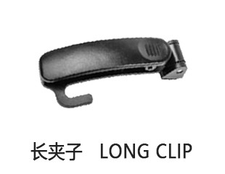 | 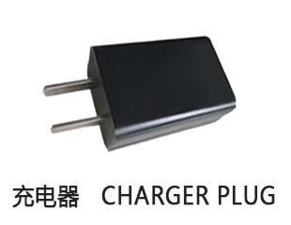 | 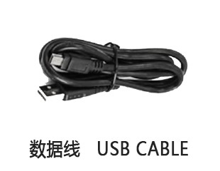
Dedicated Optional Accessories
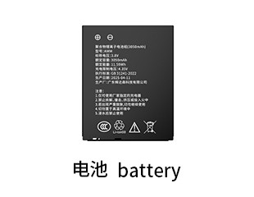 | 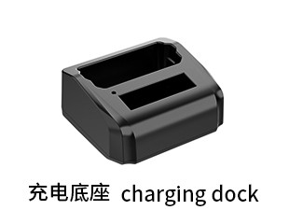
Universal Optional Accessories
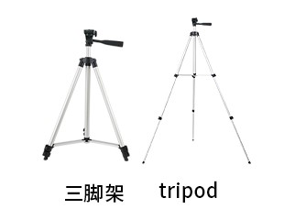 | 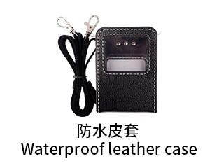 | 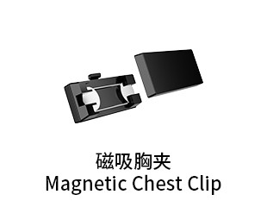 | 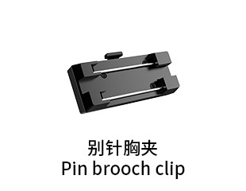 | 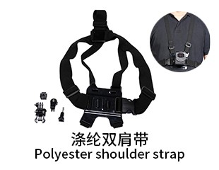
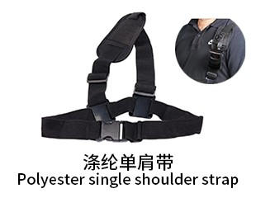 | 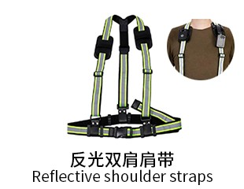 | 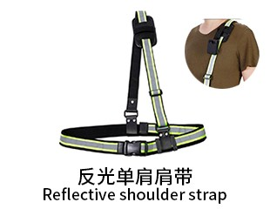 | 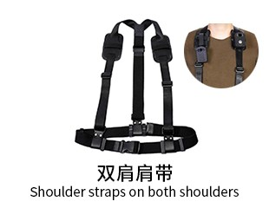 | 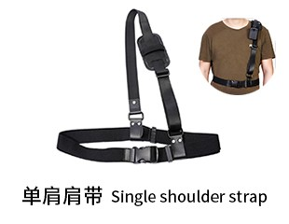
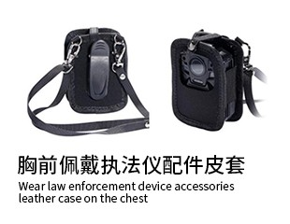 | 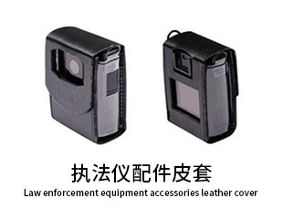 | 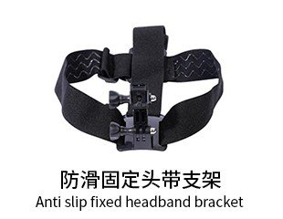 | 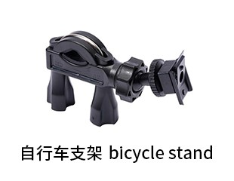 | 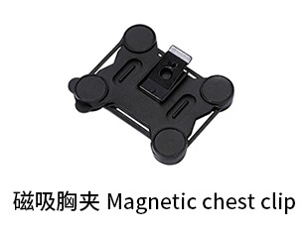
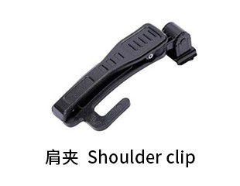 | 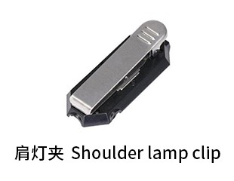 | 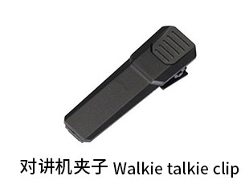 | 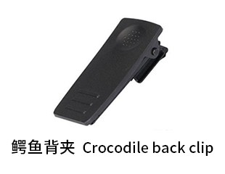 | 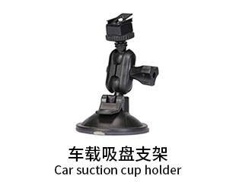
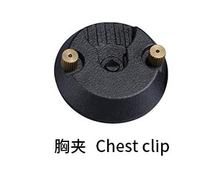 | 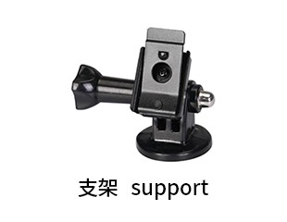 | 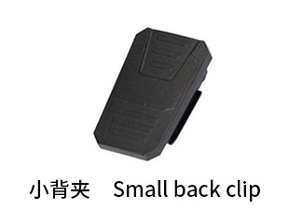 | 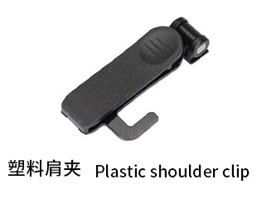 | 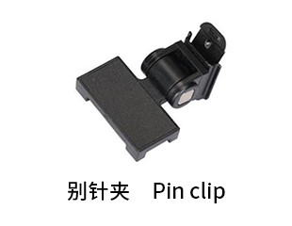
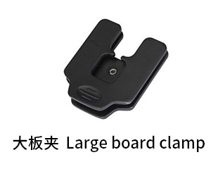 | 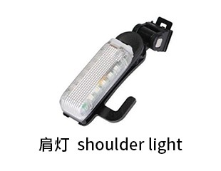 | 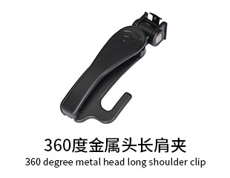 | 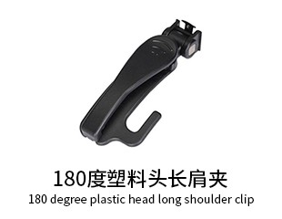 | 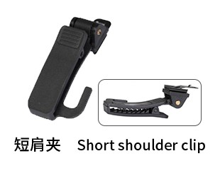
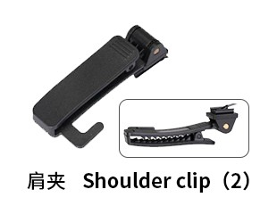 | 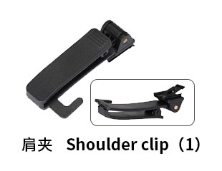 | 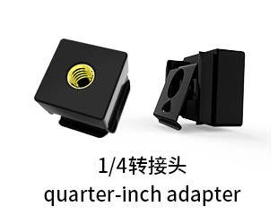
Generated At: 2026-08-21 00:44:02 | Specification Version: A77- 4G-replaceable battery-Zhanrui 2.8 standard

