TK1 -4G smart helmet
Product Specification (Model: TK1)
Product Information
Appearance Name | TK1 4G Law Enforcement Instrument
Series Model | TK1
Features | Support multiple protocols, CMSV9, MCP, Huamai, Huamai, Xintai and other platforms  GB labor insurance certification. T4IIC explosion-proof certification
Six Views
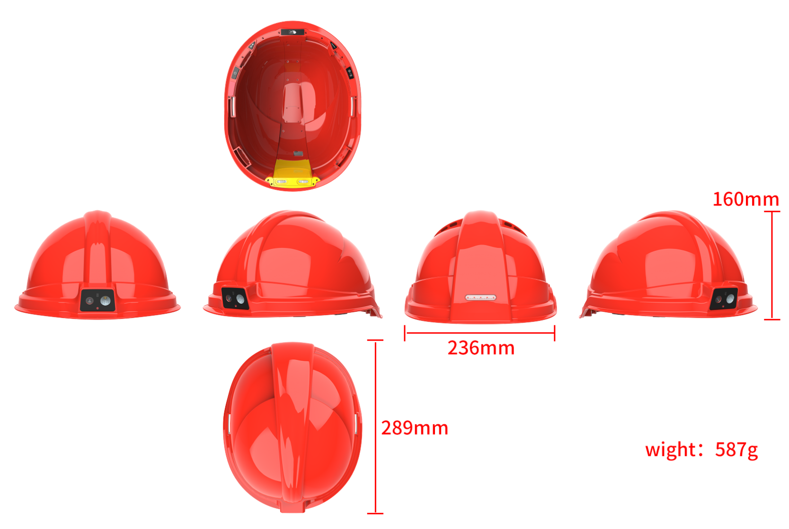
Basic Information
processor | ASR8601
operating system | Android 8
Screen size | screenless
Default battery capacity | 4200mAh
Optional battery capacity upgrade | 4600mAH
charging duration | 4 hours
Continuous recording duration | about 10 hours
standby time | >300 hours without APP, depending on APP
anti-shake | no
image format | MP4
compression format | H.264/H.265
Video size | Max. 1080P (1920*1080)30FPS
photo format | JPEG
horn | 1W
body memory | Standard 1+8G, expandable up to 512G
Rear camera (main) | 400W
Photo size | Maximum 48 million
noise reduction module | Customizable support
Lighting
laser lamp | Support auxiliary locking imaging center or laser marking
alarm lamp | Red and blue warning lights
infrared lamp | no
white light Lamp | have
Interfaces
charging interface | Type-C
headphone jack | Type-C
G-sensor | support
vibration motor | support
external camera | support
charging base | Not currently supported (need to open the base)
charging method | Battery removal and direct directly
charger | 5V-2A
USB interface | USB 2.0
Hat extended serial port | External serial communication module (RTK
Data Functions
Sim/TF Card Slot | Single Sim Single TF
WIFI | WIFI5.8 a/b/g/n/ac
Bluetooth/433 | BT5.0(BR/EDR + BLE) supports Bluetooth remote control, Bluetooth voice, Bluetooth tag positioning, etc.
positioning | Shan Beidou
compass | optional
air pressure sensor | support
temperature sensor | support
ambient light sensor | support
NFC | no
Take off your hat and alarm | Support detection of whether the hat is worn and synchronized background alarm linkage
encryption card | not support
Dimensions
Length (mm) | 289
Height (mm) | 159
Thickness (mm) | 159
Weight (g) Approx | 585g
Other Network Functions
Near power alarm | Wear a hat close to the preset voltage and broadcast a voice warning reminder. The preset voltage: 220V, 10KV, 35KV, 110KV (optional function)
video intercom | Support law enforcement instrument to platform single and two-way video intercom, support law enforcement instrument end-to-end single and two-way video intercom (requires integration of third-party software SDK)
Voice cluster intercom | Support group intercom, end-to-end intercom
voice broadcast | Support TTS voice broadcast
voice control | Currently, it can only support Chinese, and other languages need to integrate third-party speech algorithms or secondary development
Facial and license plate recognition | support
network standard | Eurasian frequency band  LTE-FDD: B1/B3/B5/B8 LTE-TDD: B34/B38/B39/B40/B41 Other frequency bands are optional
Platform Administration software | Support real-time preview/real-time positioning/trajectory playback/intercom/monitoring/remote command issuance, etc.(support secondary development of API calls, independent platform deployment, or secondary independent development of independent key values)
text overlay | Support stacking time, equipment number, law enforcement officer number, location information, speed information, and support stacking in Chinese
Command and dispatch platform docking | Support protocols: Support platforms such as 808, GB/T28181, RTMP, RTSP, ONVIF protocols and other mainstream protocols in the market to connect with audio and video, intercom, and location device information.
Basic Device Functions
Video pre-recording | support
USB flash drive function | Drive mode: After connecting to the computer, you can enter the USB flash drive mode (removable hard disk) through the upper computer on the PC side;  Non-drive mode: After connecting to the computer, directly enter USB flash drive mode (removable hard disk); one of the two modes can be selected
Replace the battery without power | no
Key Document Marker | You can mark this video file by pressing the corresponding button during the recording process;
menu language | Default Simplified Chinese/English (other languages can be customized)
continuous shooting function | The supporting device can take more than 10 photos continuously at one time
Impact alarm | Support airbag security. The product needs to have a G sensor, which can record drops and record collisions. If it has a 4G function, it can be linked in the background.
password protection function | support
video encryption | Supports AES256 encryption-SHA1-SHA2
fill light | Support the use of white LEDs for auxiliary lighting in dark situations.
Built-in small battery | None-Change battery and power off
Shooting in the middle | During the recording process, press the shoot button to take a photo individually
acquisition station | Support collection station and background management 1. Operation logs;2. Data collection and classification
data security management | Law enforcement recorders have different authority management. Primary authority can only view and playback law enforcement videos, photos, and recordings, and cannot delete or modify sensitive settings of the machine. Sensitive settings of the machine can only be made through password verification, and can only be copied, modified or deleted after connecting to a computer.
Close beat mode | Support no indicator light display and no sound reminder mode.
safe mode | Safe mode is limited to basic operations such as recording, taking photos, and recording. A password is required to enter the settings interface and playback interface.
automatically overwritten | Support automatic override/non-override
Helmet waving detection | Support hands to approach the lighting lamp to realize the switching lighting function
Safety helmet flashing warning light | Support alternating red and blue flashing warning lights on the back of the helmet
Others
protection grade | IP54 dropped 2 meters
low-temperature compatibility | Corresponding low-temperature batteries should be prepared for inspection and low-temperature areas. The low-temperature-30 ℃ battery life of a single battery should be more than 2 hours. Normal temperature batteries should be standard. Normal temperature batteries and low-temperature batteries have different densities and operating environments.
injection molding process | monochrome injection molding
Storage relative humidity | 63%(30℃)
storage temperature | -40~60℃
operating relative humidity | 40%~80%
operating temperature | -20~55℃
Packing Information
Box gauge: length × width × height mm
Number of boxes: | 8 PCS/box
Weight of the whole box:
Package: L × W × H mm
Net weight of packaging box:
Machine net weight:
Weight of outer packaging box: | 1/KG
Standard Accessories
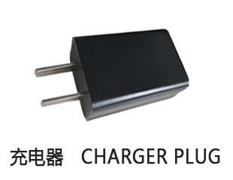 | 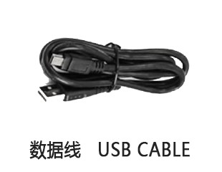
Generated At: 2026-08-21 00:43:54 | Specification Version: TK1 -4G smart helmet

