XP1 badge stand-alone Jieli-built-in battery
Product Specification (Model: 胸牌系列)
Product Information
Appearance Name | Badge series
Series Model | 胸牌系列
Features | With a small screen for instant viewing, it is easy to operate the menu. Instant playback, etc.  A variety of clips can be optional or customized, with multi-functional clips.  1440P/WiFi as standard by default
Six Views
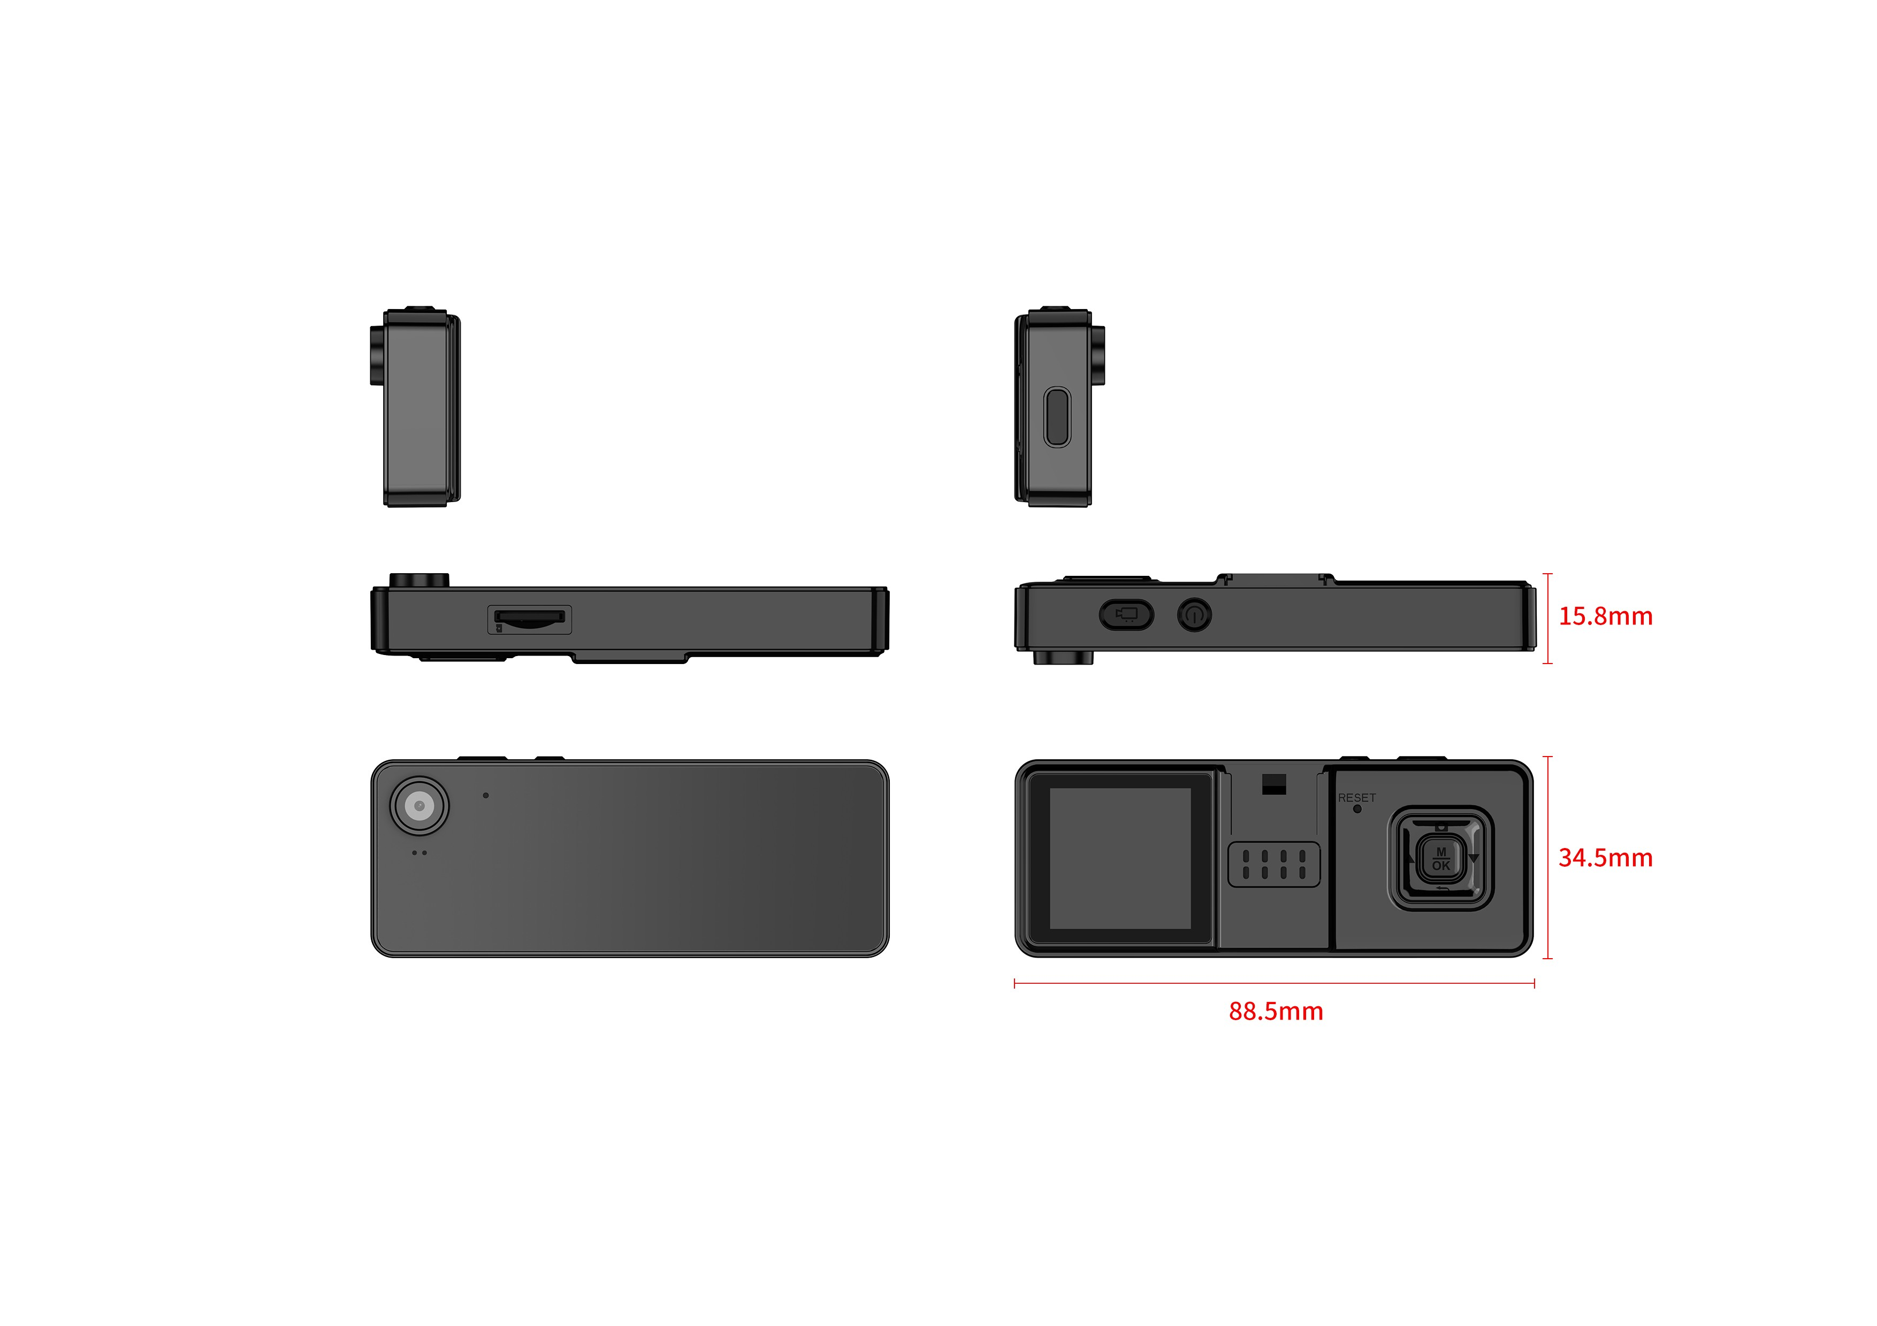
Function Diagram
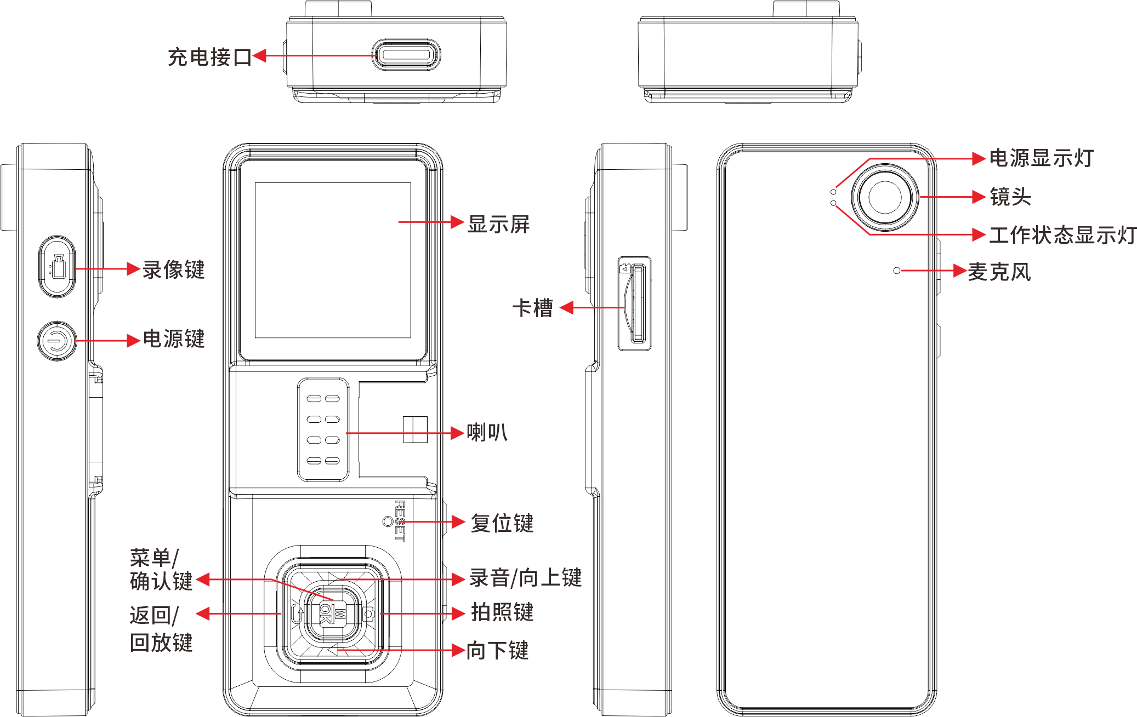
Basic Information
processor | no
operating system | no
Screen size | 1.54 inch screen
Default battery capacity | 1400mAh
Optional battery capacity upgrade | no
charging duration | 3 hours
Continuous recording duration | about 7.5 hours
standby time | about 7.5 hours
anti-shake | no
image format | MP4
compression format | H264
Video size | Maximum 2K(2560*1440)30FPS
photo format | JPEG
horn | 1W
body memory | no
Rear camera (main) | 200W
Photo size | Maximum 58 million
Lighting
laser lamp | no
white light Lamp | no
alarm lamp | no
infrared lamp | no
Interfaces
charging interface | Type-C
G-sensor | not support
vibration motor | not support
external camera | not support
charging method | Complete line charging
charger | 5V-1A
USB interface | USB 2.0
Data Functions
WIFI | Point-to-point AP
Bluetooth/433 | no
positioning | no
Dimensions
Length (mm) | 88.5
Height (mm) | 34.5
Thickness (mm) | 15.8
Weight (g) Approx | 50
Basic Device Functions
Video pre-recording | not support
Video extension | support
Impact alarm | no
night vision | no
fill light | no
USB flash drive function | Drive mode: After connecting to the computer, you can enter the USB flash drive mode (removable hard disk) through the upper computer on the PC side;  Non-drive mode: After connecting to the computer, directly enter USB flash drive mode (removable hard disk); one of the two modes can be selected
menu language | Default Simplified Chinese/English (other languages can be customized)
Key Document Marker | You can mark this video file by pressing the corresponding button during the recording process;
continuous shooting function | The supporting device can take more than 10 photos continuously at one time
password protection function | support
Close beat mode | Support no indicator light display and no sound reminder mode.
Shooting in the middle | During the recording process, press the shoot button to take a photo individually
video encryption | not support
automatically overwritten | Support automatic override/non-override
in-vehicle functions | Support vehicle-mounted certificate collection, and realize automatic video recording and evidence collection when the car ignites and turns on, and automatic shutdown after parking and flameout.
safe mode | Safe mode is limited to basic operations such as recording, taking photos, and recording. A password is required to enter the settings interface and playback interface.
acquisition station | Support collection station and background management 1. Operation logs;2. Data collection and classification
data security management | Law enforcement recorders have different authority management. Primary authority can only view and playback law enforcement videos, photos, and recordings, and cannot delete or modify sensitive settings of the machine. Sensitive settings of the machine can only be made through password verification, and can only be copied, modified or deleted after connecting to a computer.
motion detection | Supports automatic recording and stopping of recording based on scene changes and still
One-click shortcut function | Support one-click quick start of recording, one-click start of recording function (no need to start the power button separately)
Others
protection grade | IP50 fell 2 meters
injection molding process | monochrome injection molding
low-temperature compatibility | Corresponding low-temperature batteries should be prepared for inspection and low-temperature areas. The low-temperature-30 ℃ battery life of a single battery should be more than 2 hours. Normal temperature batteries should be standard. Normal temperature batteries and low-temperature batteries have different densities and operating environments.
Storage relative humidity | 63%(30℃)
storage temperature | -40~60℃
operating relative humidity | 40%~80%
operating temperature | -20~55℃
Packing Information
Box gauge: length × width × height mm
Weight of the whole box:
Number of boxes: | 40 PCS/box
Package: L × W × H mm
Net weight of packaging box:
Machine net weight:
Weight of outer packaging box: | 550g
Standard Accessories
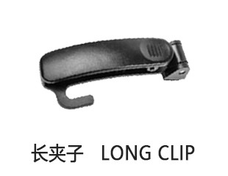 | 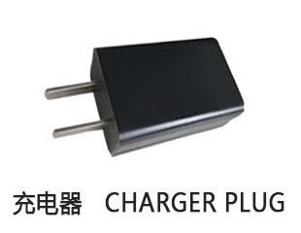 | 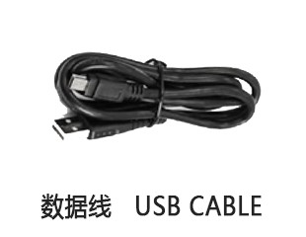
Universal Optional Accessories
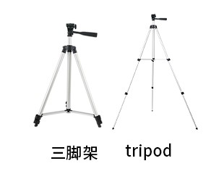 | 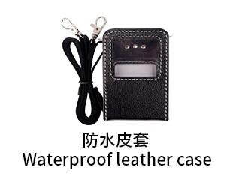 | 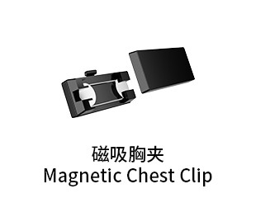 | 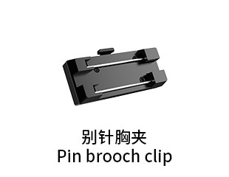 | 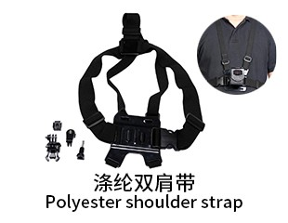
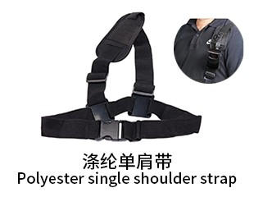 | 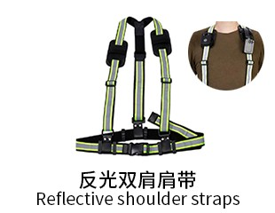 | 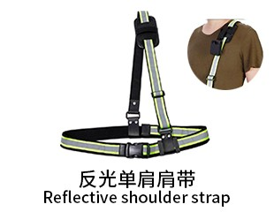 | 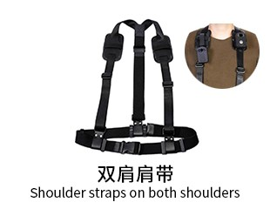 | 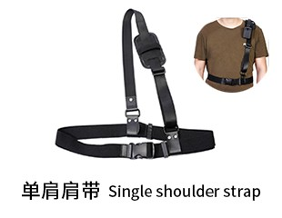
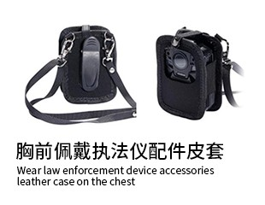 | 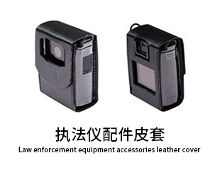 | 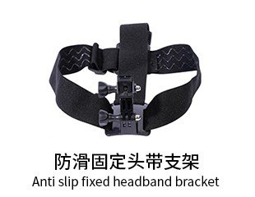 | 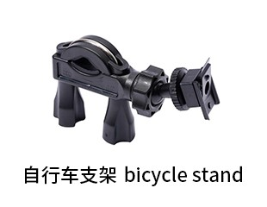 | 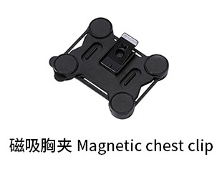
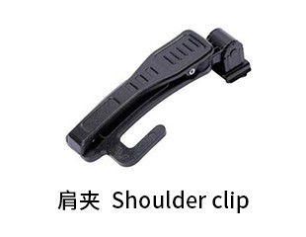 | 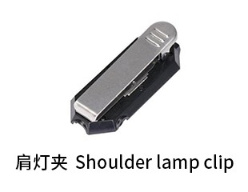 | 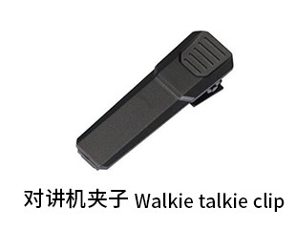 | 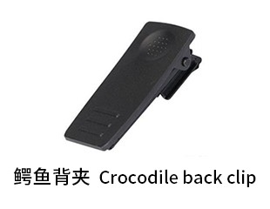 | 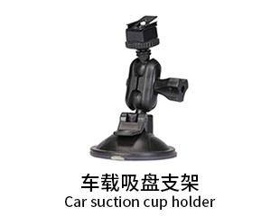
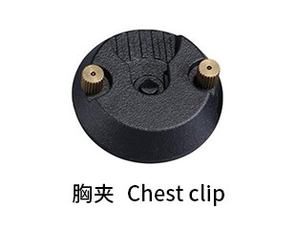 | 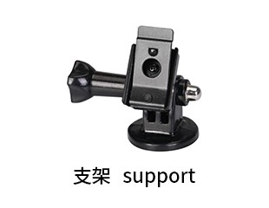 | 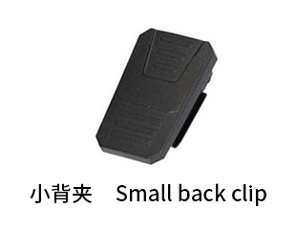 | 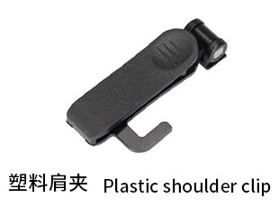 | 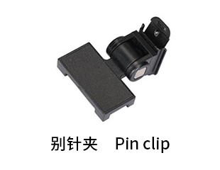
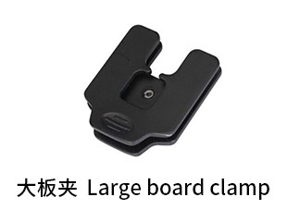 | 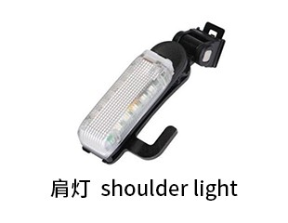 | 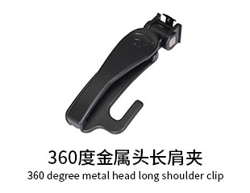 | 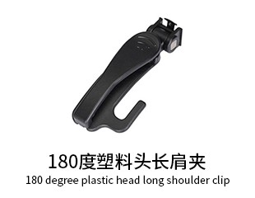 | 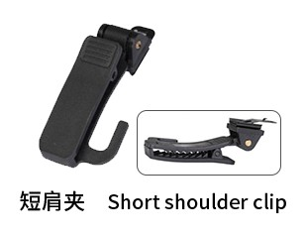
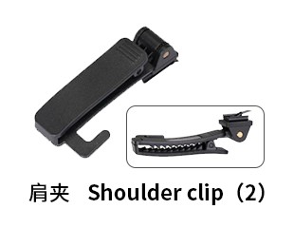 | 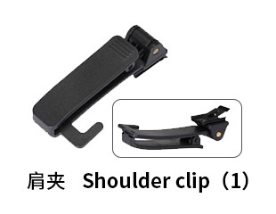 | 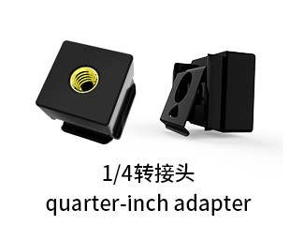
Generated At: 2026-08-21 00:44:21 | Specification Version: XP1 badge stand-alone Jieli-built-in battery

