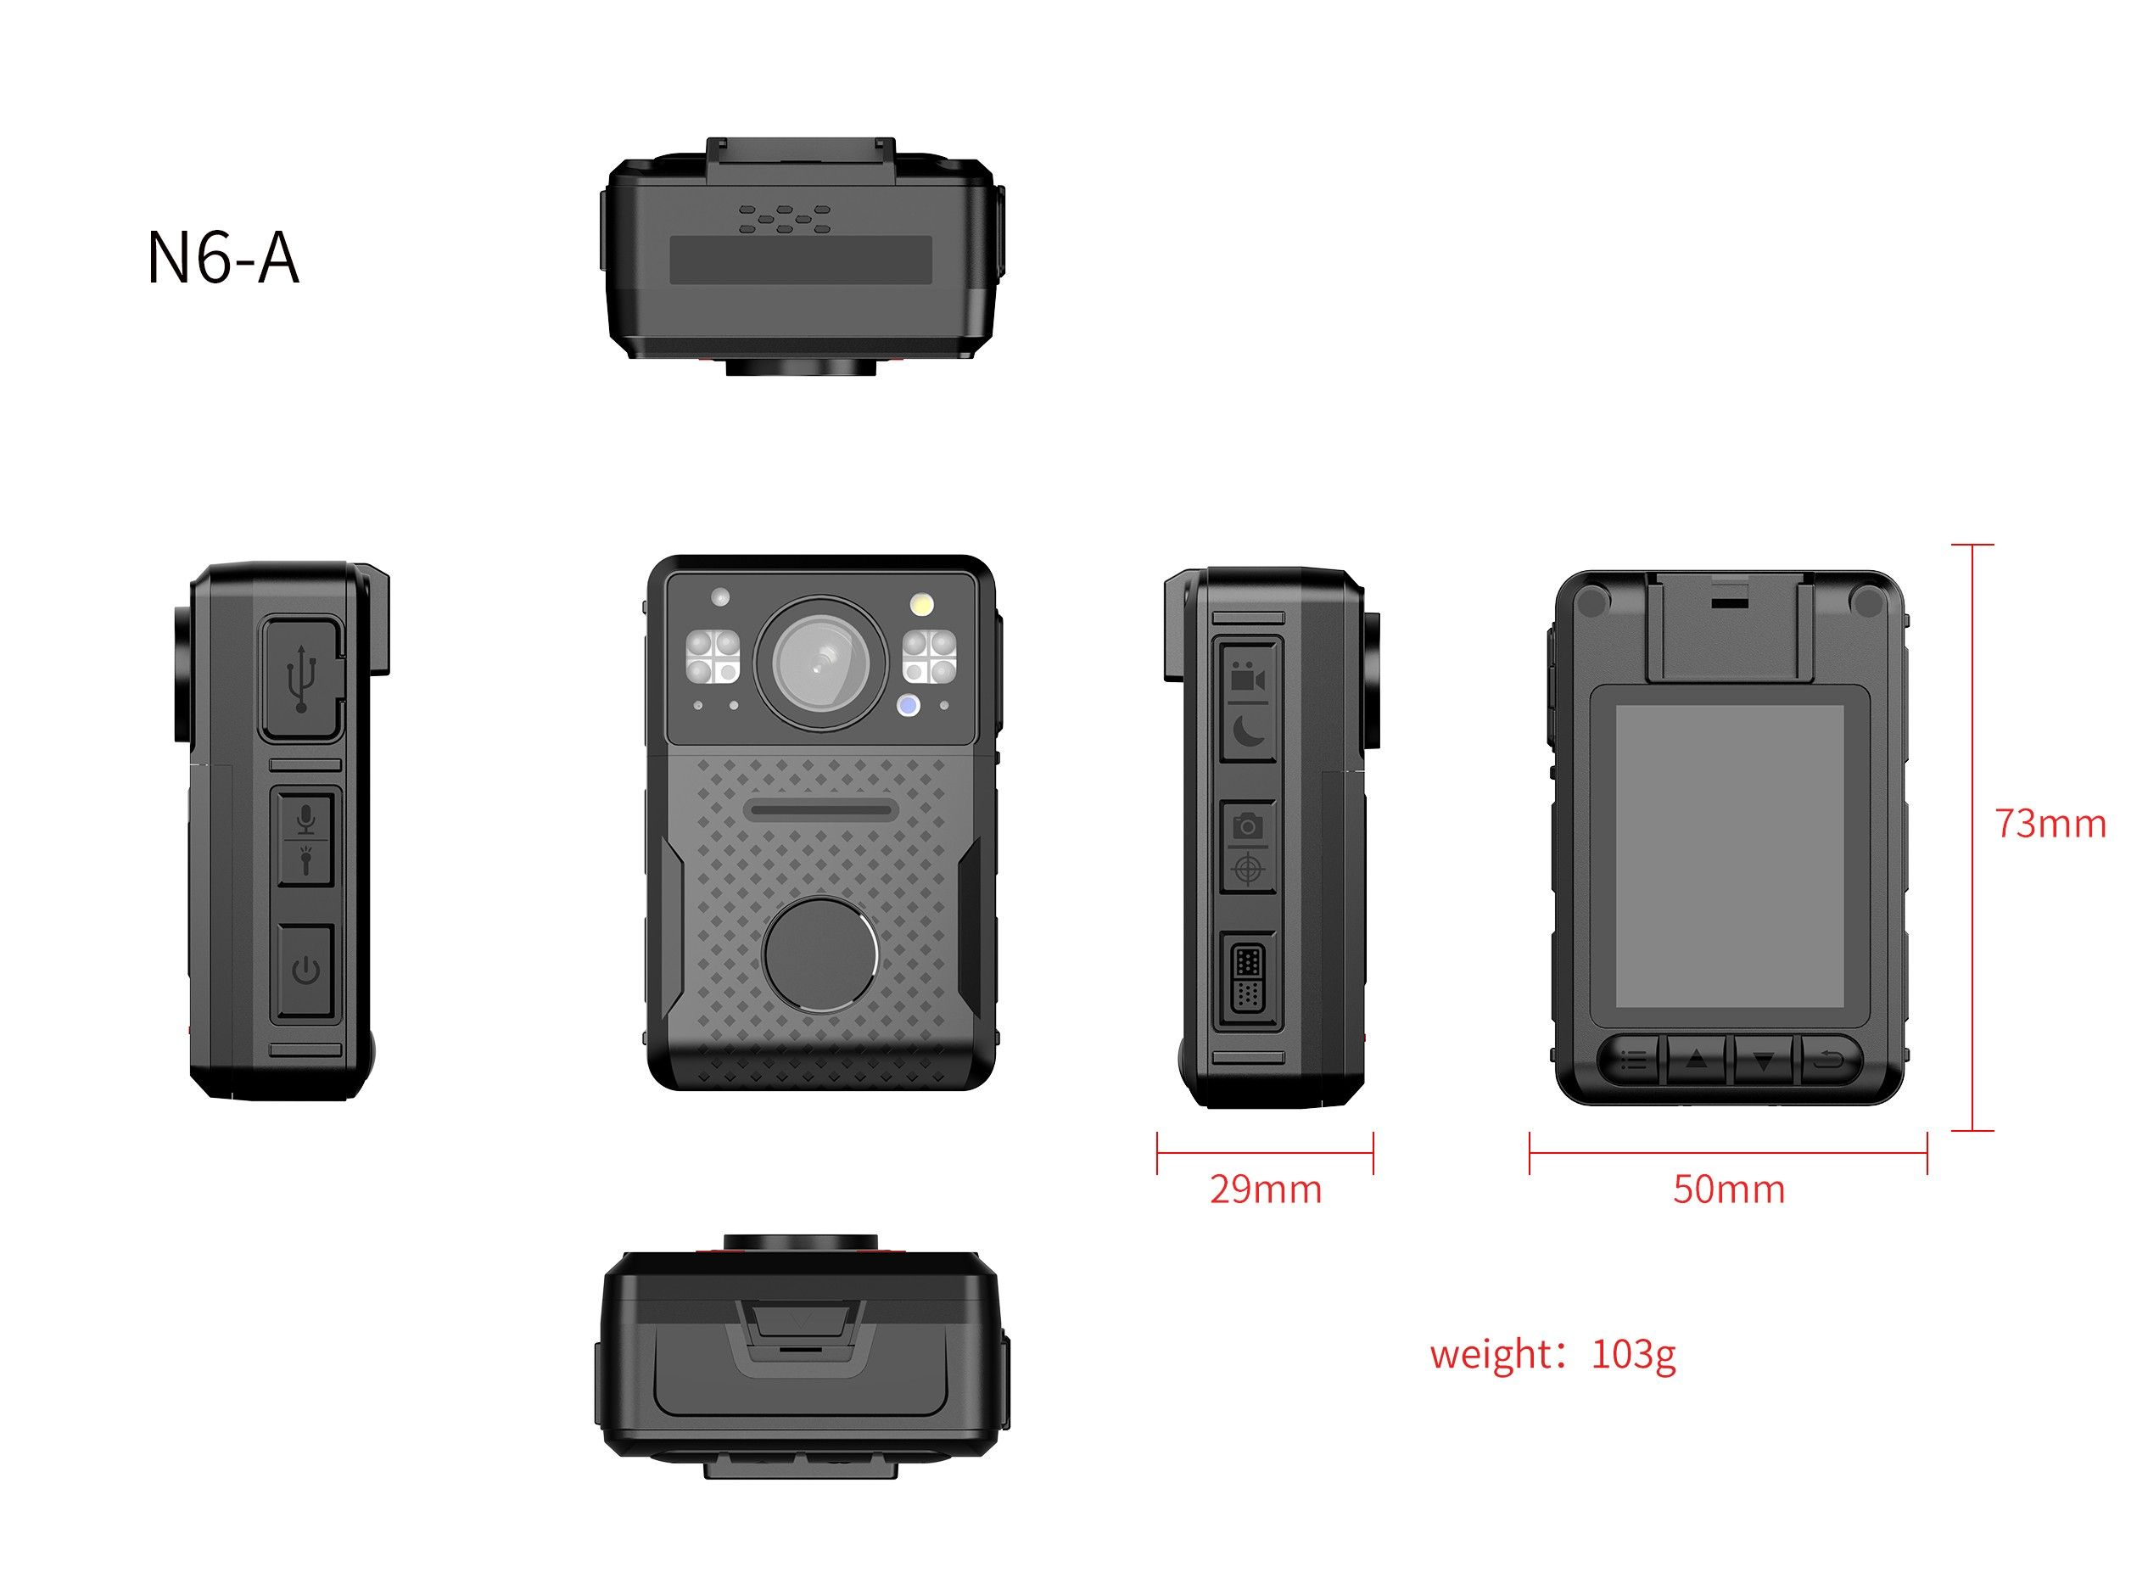

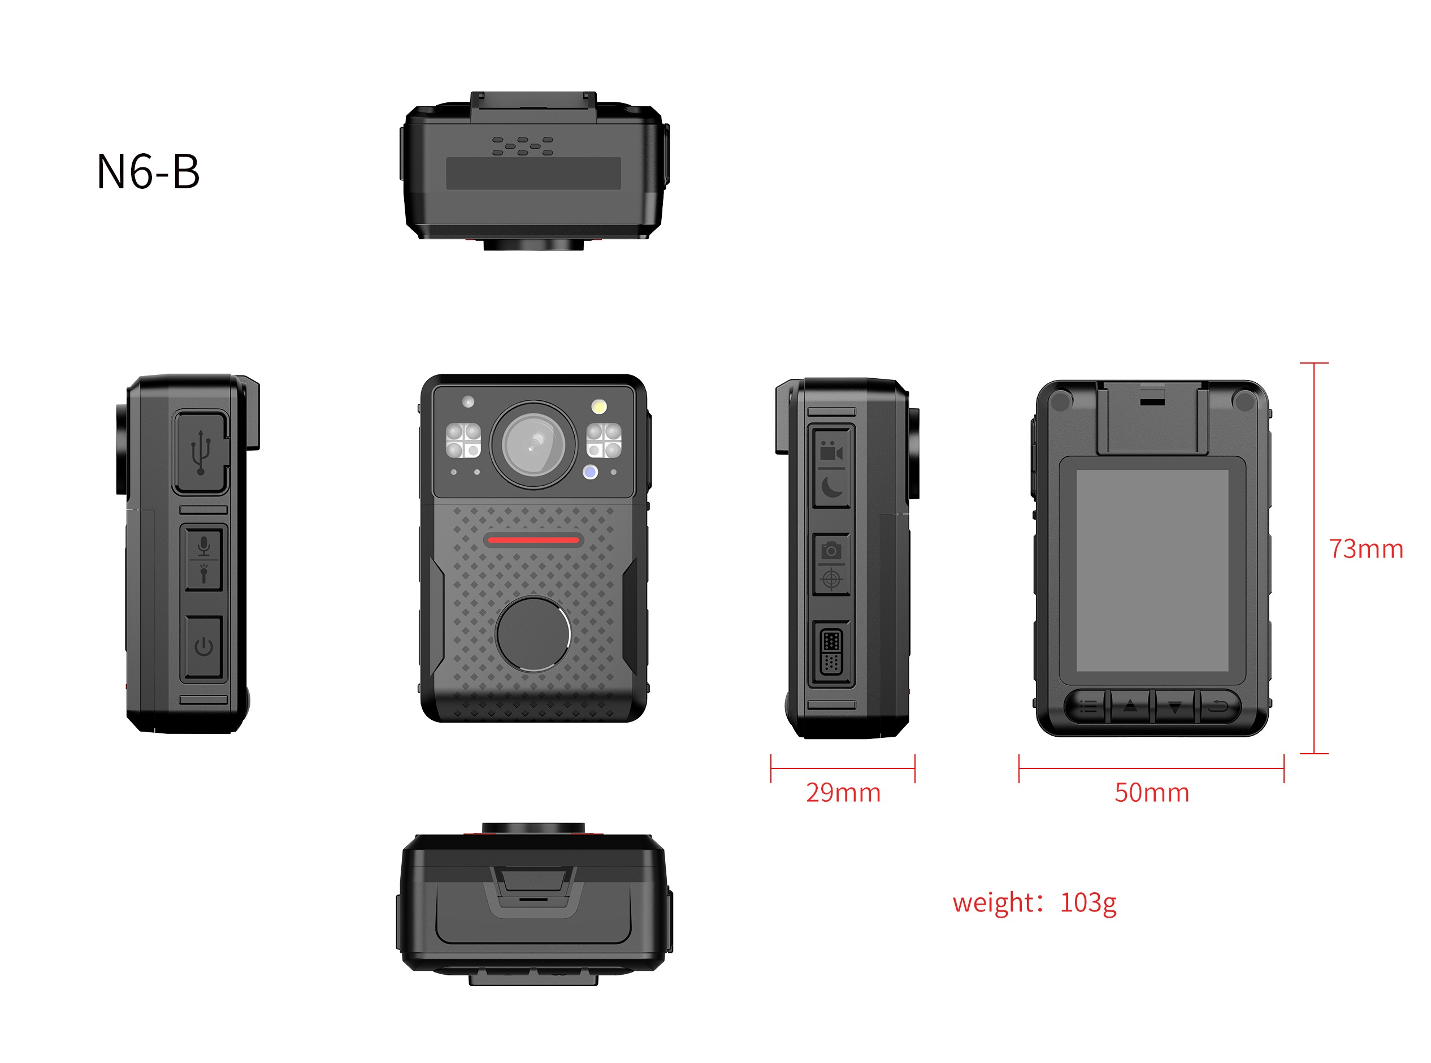

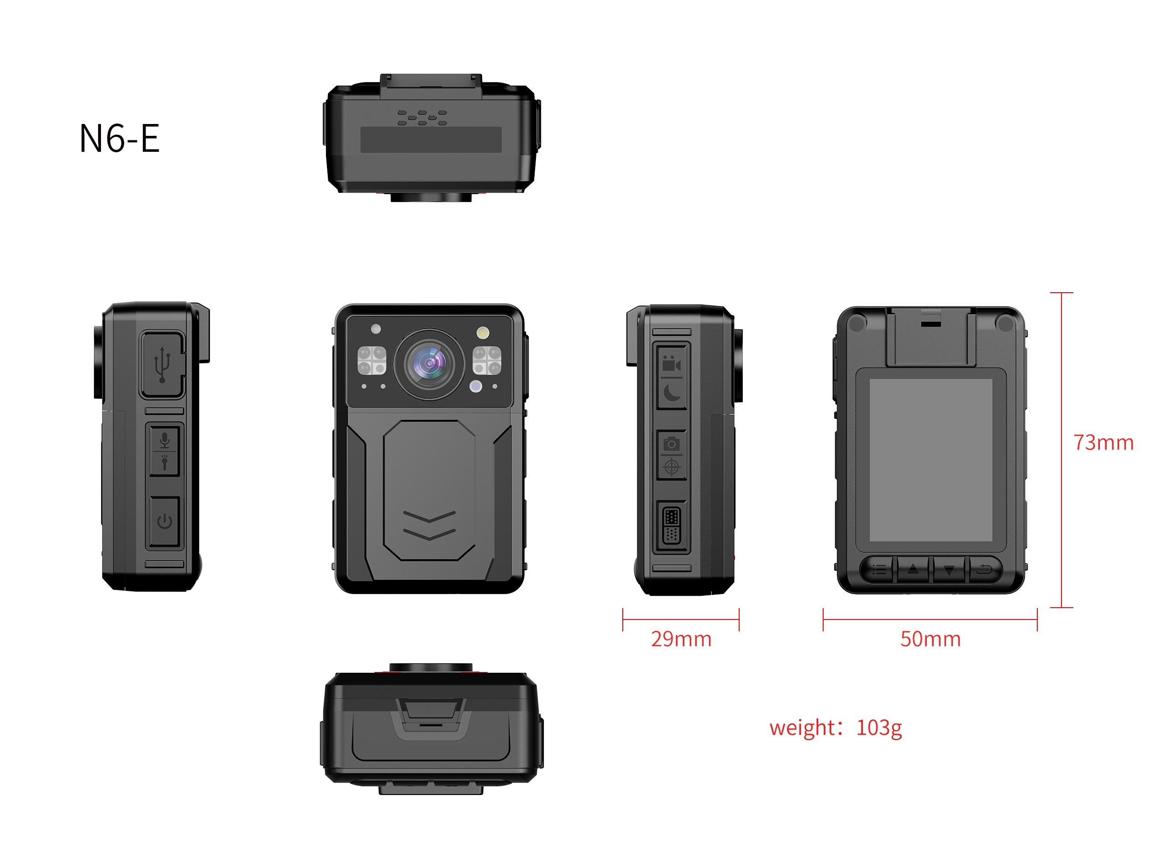

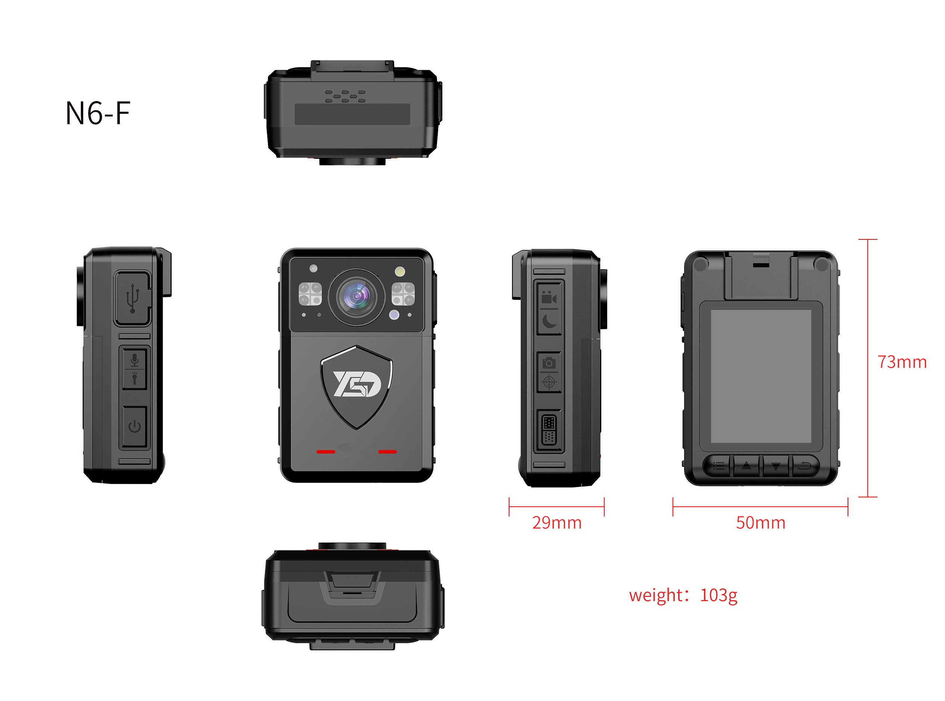

N6 series ID diagram display
Product Specification (Model: )
Product Information
Appearance Name
Series Model
Generated At: 2026-08-21 01:26:31 | Specification Version: N6 series ID diagram display

