D1- 400W Law Enforcement Recorder
Product Specification (Model: D1-400W 执法记录仪)
Product Information
Appearance Name | D1 series
Series Model | D1-400W 执法记录仪
Six Views
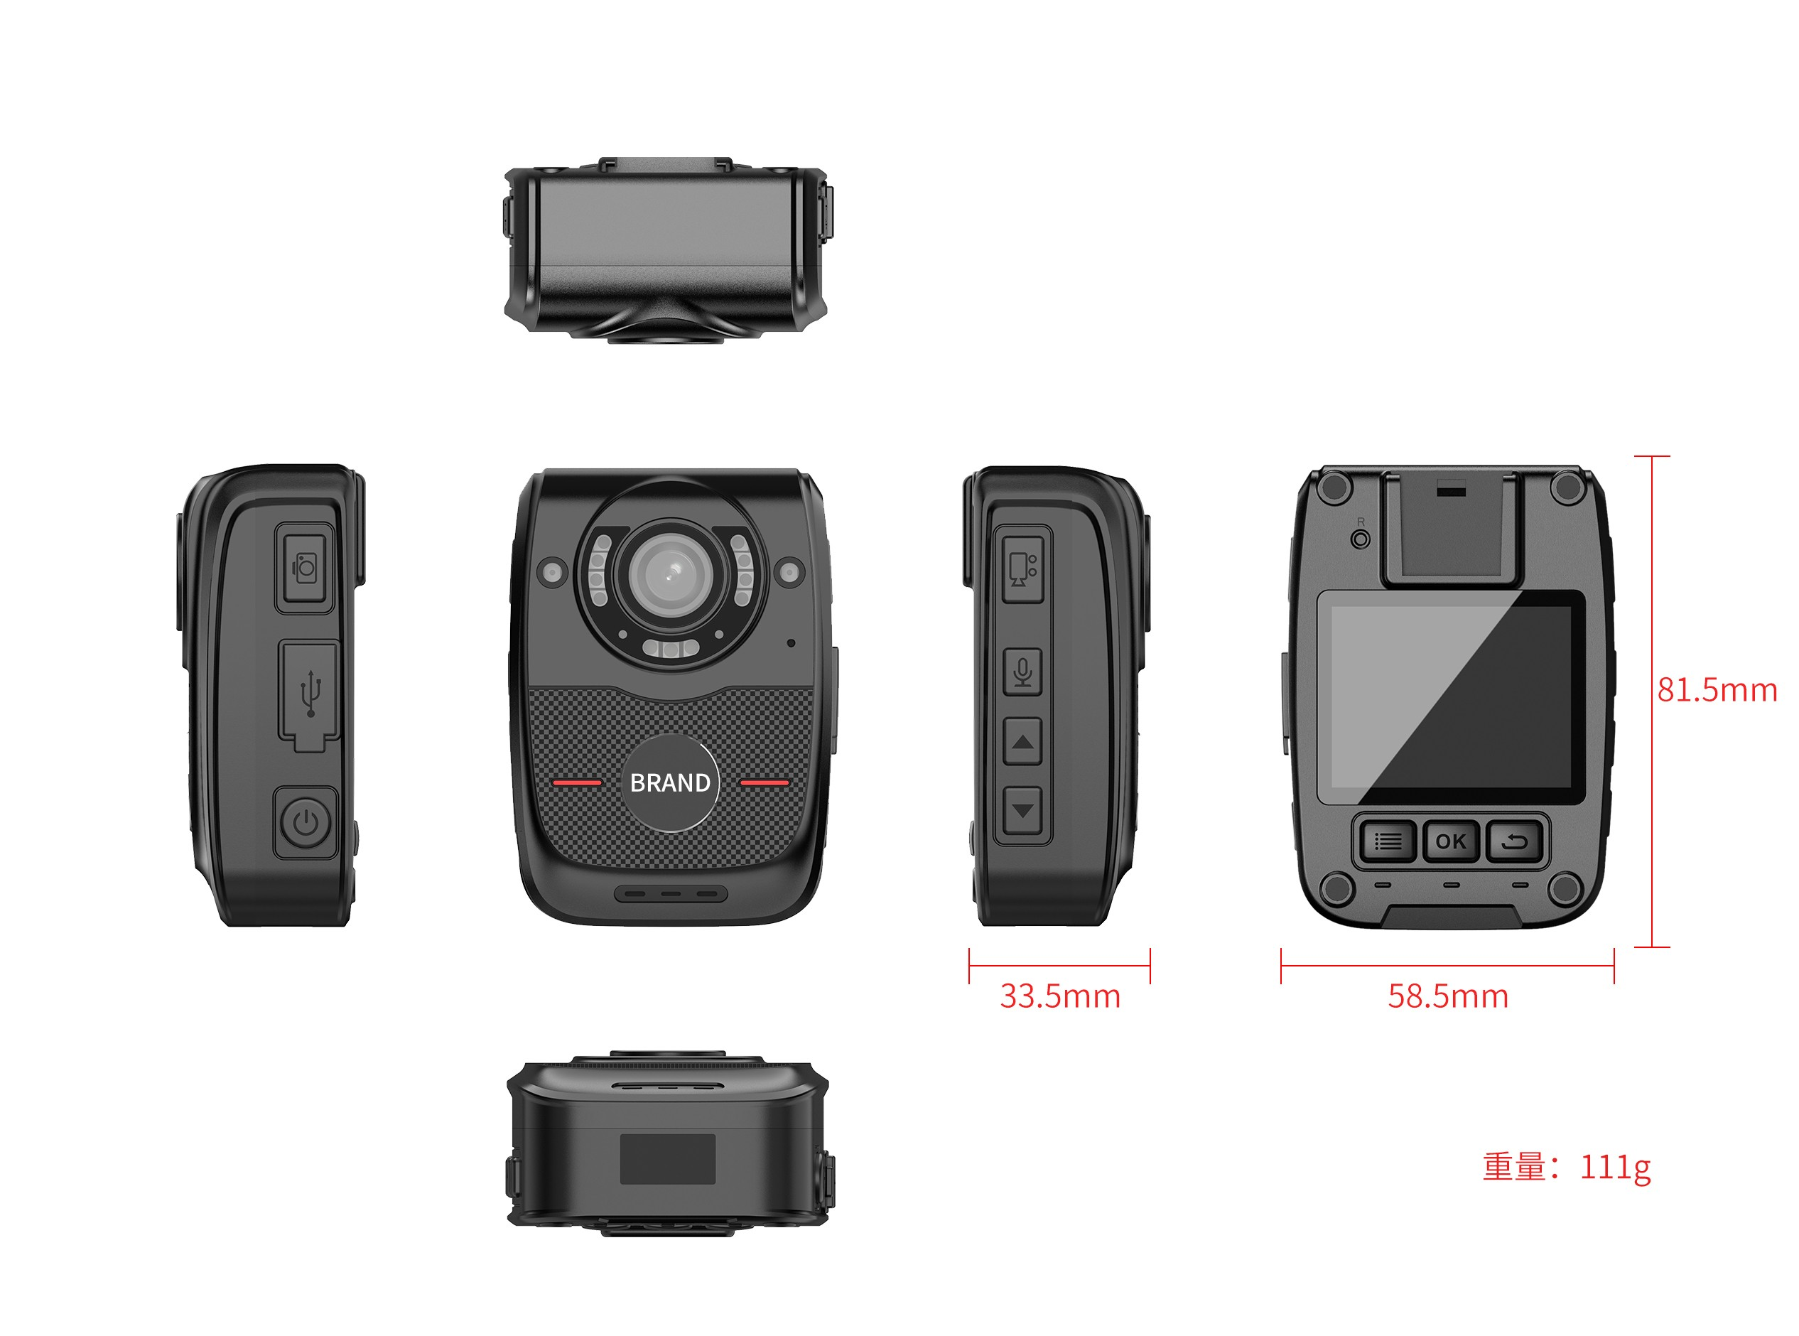
Function Diagram
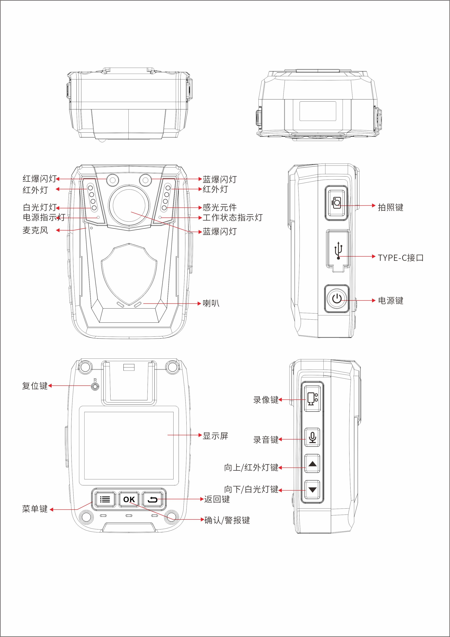
Basic Information
processor | no
operating system | no
Screen size | 2.0 inch horizontal screen
Default battery capacity | 2600mAh
Optional battery capacity upgrade | no
charging duration | 4 hours
Continuous recording duration
standby time | about 20 hours
anti-shake | no
image format | MOV
compression format | H264
Video size | Maximum 4K(3840*2160)30FPS
photo format | JPEG
horn | 1W
body memory | Scalable up to 512G
Rear camera (main) | 400W
Photo size | Maximum 54 million
Lighting
laser lamp | Support auxiliary locking imaging center or laser marking
white light Lamp | have
alarm lamp | Red and blue warning lights
infrared lamp | have
Interfaces
charging interface | Type-C
G-sensor | support
vibration motor | not support
external camera | not support
charging method | Complete line charging
charger | 5V-1A
USB interface | USB 2.0
Data Functions
WIFI | no
Bluetooth/433 | no
positioning | no
Dimensions
Length (mm)
Height (mm)
Thickness (mm)
Weight (g) Approx
Basic Device Functions
Video pre-recording | support
Video extension | support
Impact alarm | no
night vision | Automatic or manual night vision switching, support for high-power red lights
fill light | Support the use of white LEDs for auxiliary lighting in dark situations.
USB flash drive function | Drive mode: After connecting to the computer, you can enter the USB flash drive mode (removable hard disk) through the upper computer on the PC side;  Non-drive mode: After connecting to the computer, directly enter USB flash drive mode (removable hard disk); one of the two modes can be selected
menu language | Default Simplified Chinese/English (other languages can be customized)
Key Document Marker | You can mark this video file by pressing the corresponding button during the recording process;
continuous shooting function | The supporting device can take more than 10 photos continuously at one time
password protection function | support
Close beat mode | Support no indicator light display and no sound reminder mode.
Shooting in the middle | During the recording process, press the shoot button to take a photo individually
video encryption | Supports AES256 encryption-SHA1-SHA2
automatically overwritten | Support automatic override/non-override
in-vehicle functions | Support vehicle-mounted certificate collection, and realize automatic video recording and evidence collection when the car ignites and turns on, and automatic shutdown after parking and flameout.
safe mode | Safe mode is limited to basic operations such as recording, taking photos, and recording. A password is required to enter the settings interface and playback interface.
acquisition station | Support collection station and background management 1. Operation logs;2. Data collection and classification
data security management | Law enforcement recorders have different authority management. Primary authority can only view and playback law enforcement videos, photos, and recordings, and cannot delete or modify sensitive settings of the machine. Sensitive settings of the machine can only be made through password verification, and can only be copied, modified or deleted after connecting to a computer.
motion detection | Supports automatic recording and stopping of recording based on scene changes and still
One-click shortcut function | Support one-click quick start of recording, one-click start of recording function (no need to start the power button separately)
Others
protection grade | IP66 fell 2 meters
injection molding process | monochrome injection molding
low-temperature compatibility | Corresponding low-temperature batteries should be prepared for inspection and low-temperature areas. The low-temperature-30 ℃ battery life of a single battery should be more than 2 hours. Normal temperature batteries should be standard. Normal temperature batteries and low-temperature batteries have different densities and operating environments.
Storage relative humidity | 63%(30℃)
storage temperature | -40~60℃
operating relative humidity | 40%~80%
operating temperature | -20~55℃
Packing Information
Box gauge: length × width × height mm
Weight of the whole box:
Number of boxes: | --------------------
Package: L × W × H mm
Net weight of packaging box:
Machine net weight:
Weight of outer packaging box: | 550g
Standard Accessories
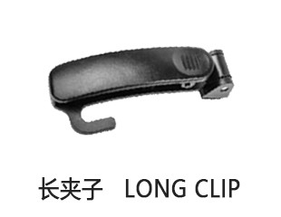 | 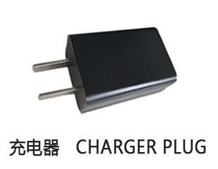 | 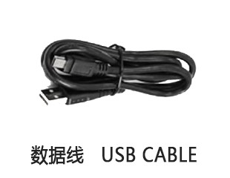
Universal Optional Accessories
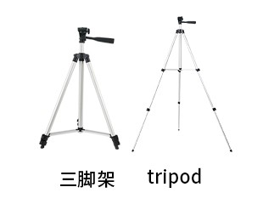 | 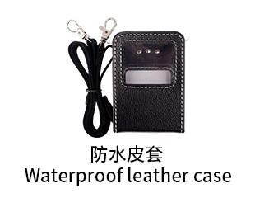 | 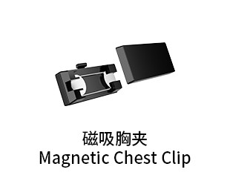 | 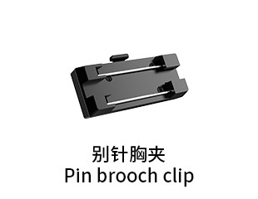 | 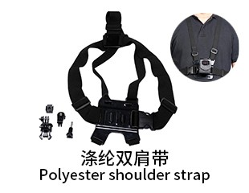
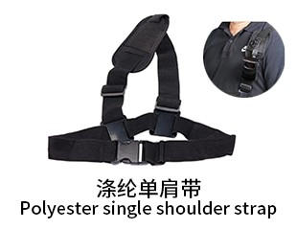 | 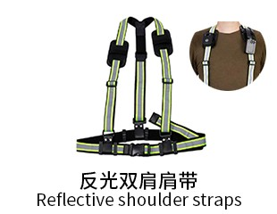 | 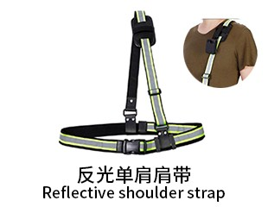 | 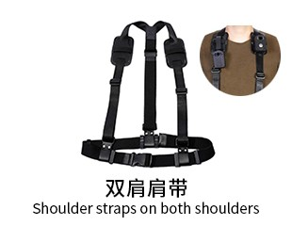 | 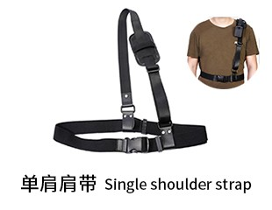
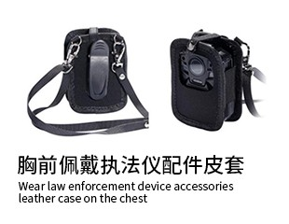 | 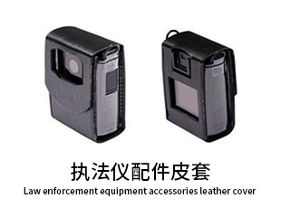 | 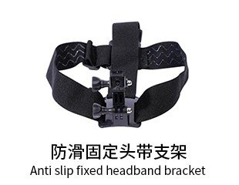 | 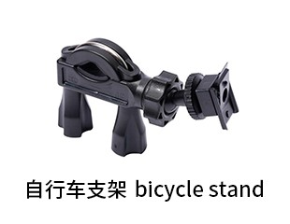 | 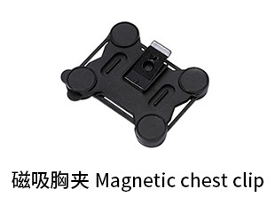
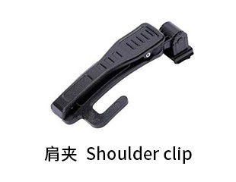 | 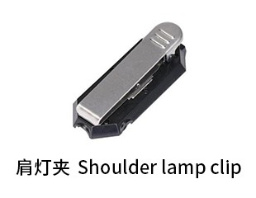 | 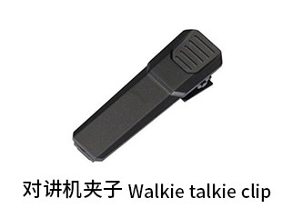 | 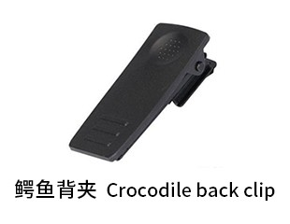 | 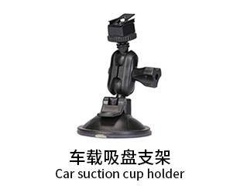
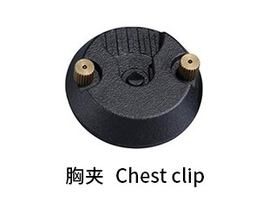 | 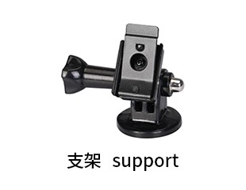 | 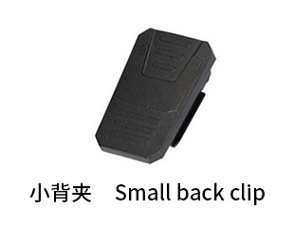 | 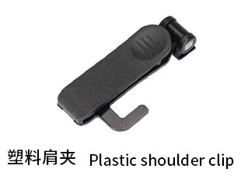 | 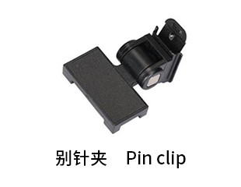
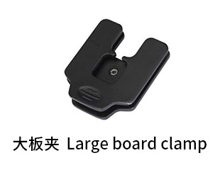 | 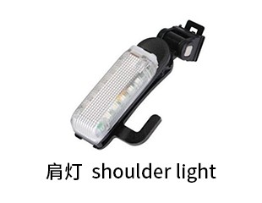 | 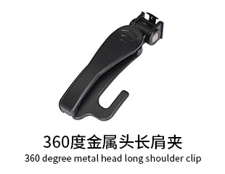 | 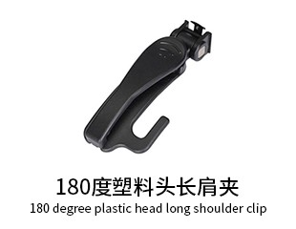 | 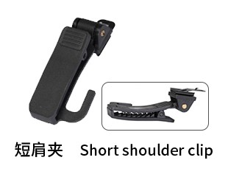
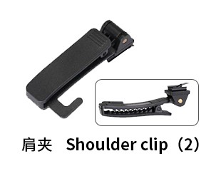 | 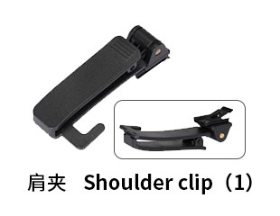 | 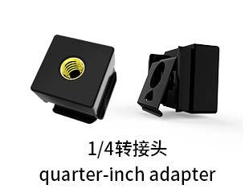
Generated At: 2026-08-21 00:44:10 | Specification Version: D1- 400W Law Enforcement Recorder

