AWS-CAT1-4G Law Enforcement Recorder-Built-in Battery-851
Product Specification (Model: AWS-CAT1-4G执法记录仪-内置电池-851)
Product Information
Appearance Name | AWS-CAT1-4G Law Enforcement Recorder-Built-in Battery-851
Series Model | AWS-CAT1-4G执法记录仪-内置电池-851
Six Views
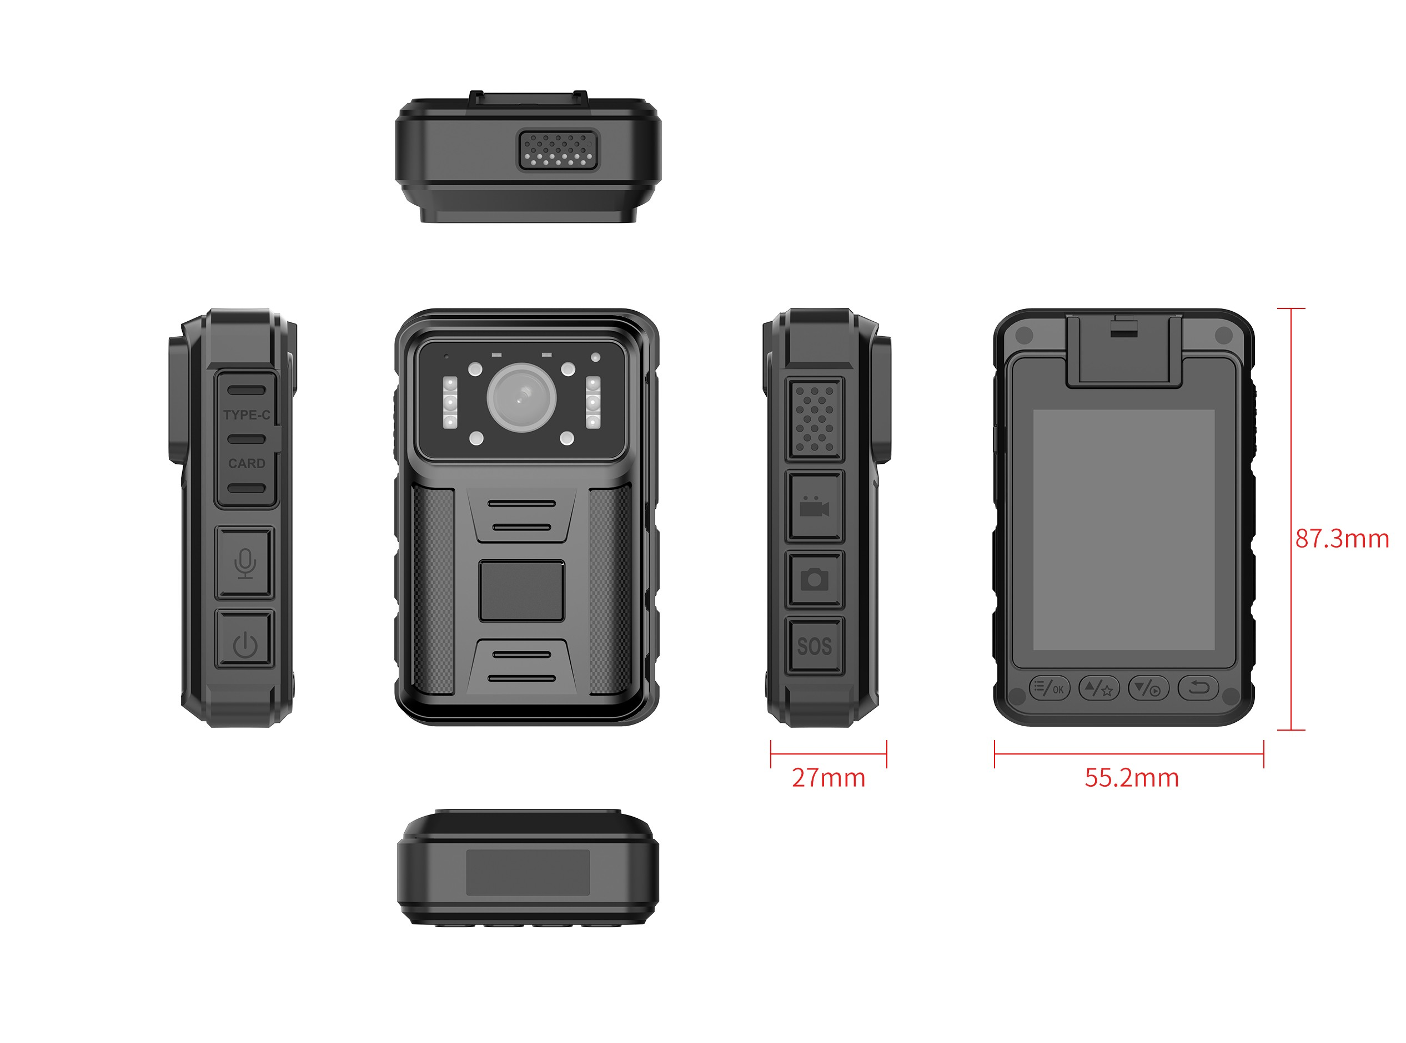
Function Diagram
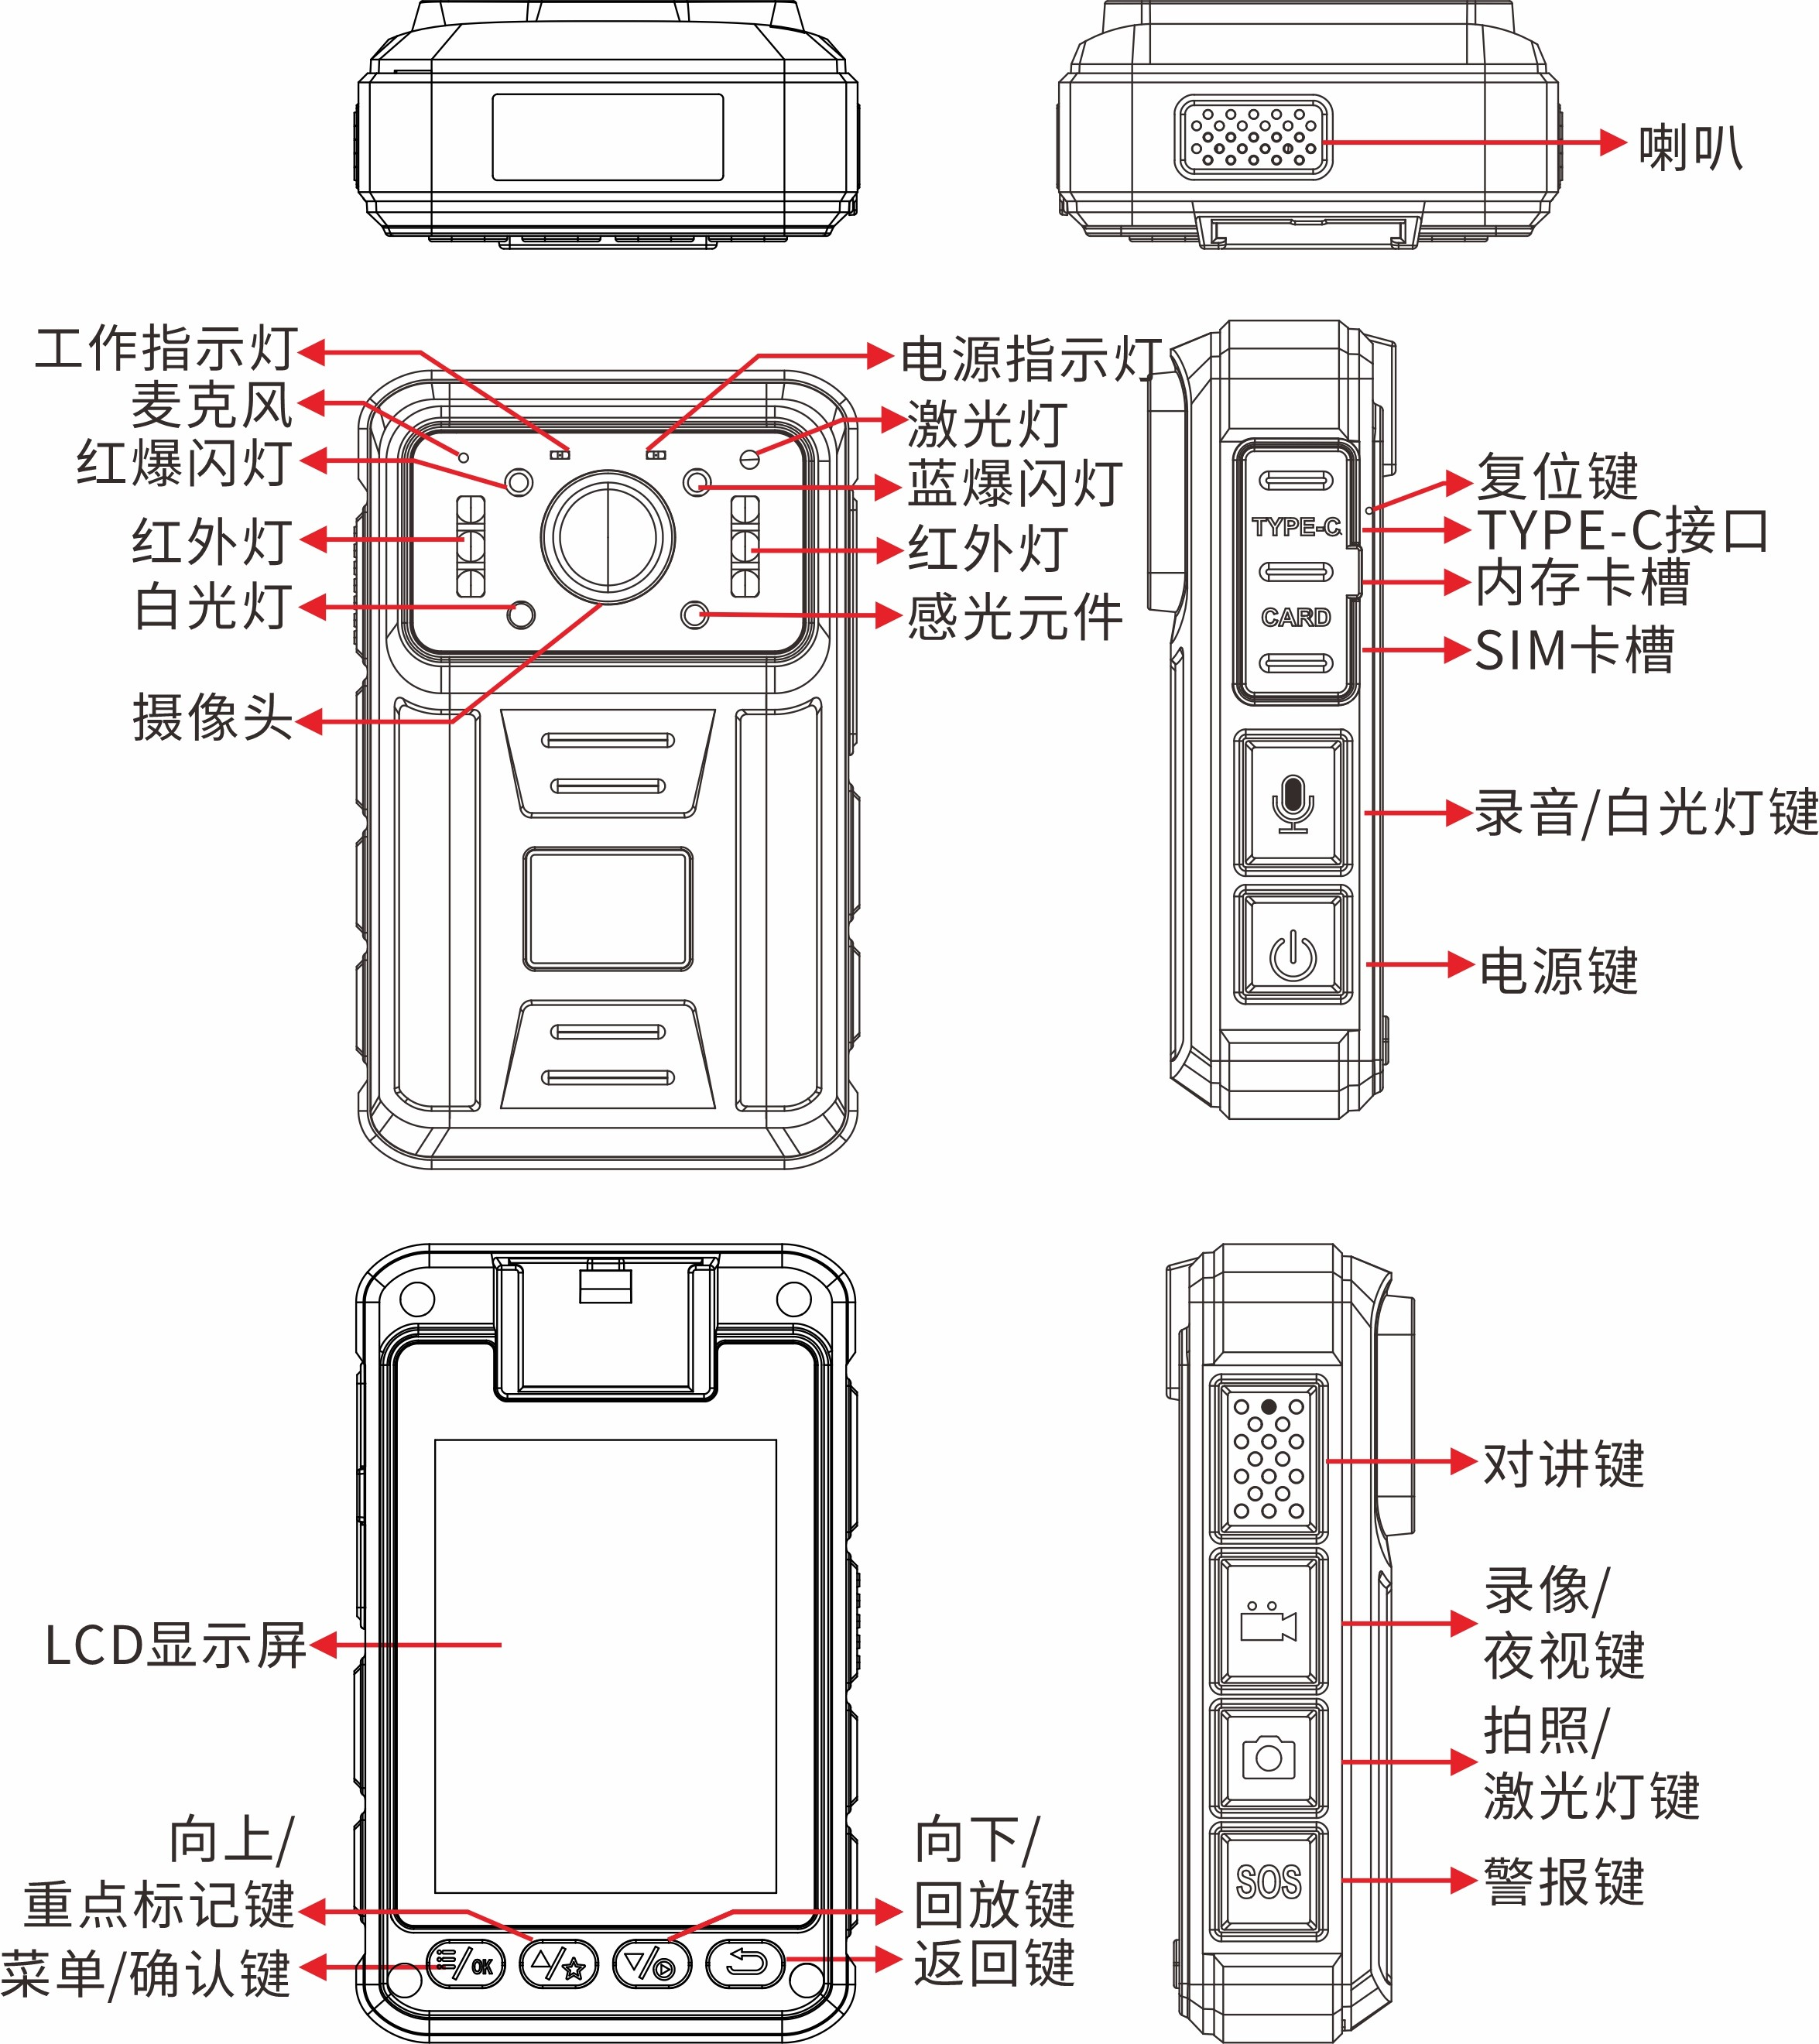
Basic Information
processor | Quan Zhi 851
operating system | Linux
Screen size | --------------------
Default battery capacity | 3000mAh
Optional battery capacity upgrade | 4200mAh
charging duration | 3 hours
Continuous recording duration | about 13 hours
standby time | empty
anti-shake | no
image format | MP4
compression format | H.264/H.265
Video size | Maximum 2K(2560*1440)30FPS
photo format | JPEG
horn | 1W
body memory | Scalable up to 512G
Rear camera (auxiliary AF) | no
Front camera (screen) | no
Rear camera (main) | 200W(optional 400W)
Photo size | Maximum 54 million
noise reduction module | not support
Lighting
laser lamp | Support auxiliary locking imaging center or laser marking
alarm lamp | Red and blue warning lights
infrared lamp | have
white light Lamp | have
Interfaces
charging interface | Type-C
headphone jack | no
G-sensor | support
vibration motor | not support
external camera | support
charging base | not support
charging method | Complete line charging
charger | 5V-2A
USB interface | USB 2.0
Data Functions
Sim/TF Card Slot | Single Sim Single TF
WIFI | WIFI5.8 a/b/g/n/ac
Bluetooth/433 | no
positioning | (Optional Beidou) Multi-mode Global GLONASS+GPS+Galileo+Compass
compass | not support
air pressure sensor | not support
temperature sensor | not support
ambient light sensor | not support
NFC | no
encryption card | not support
Dimensions
Length (mm) | 55.2
Height (mm) | 87.3
Thickness (mm) | 40
Weight (g) Approx | 145
Other Network Functions
video intercom | Support law enforcement instrument to platform single and two-way video intercom, support law enforcement instrument end-to-end single and two-way video intercom (requires integration of third-party software SDK)
Voice cluster intercom | Support group intercom, end-to-end intercom
voice broadcast | Support TTS voice broadcast
voice control | not support
Facial and license plate recognition | not support
network standard | Eurasian frequency band  LTE-FDD: B1/B3/B5/B8 LTE-TDD: B34/B38/B39/B40/B41 Other frequency bands are optional
Platform Administration software | Support real-time preview/real-time positioning/trajectory playback/intercom/monitoring/remote command issuance, etc.(support secondary development of API calls, independent platform deployment, or secondary independent development of independent key values)
text overlay | Support stacking time, equipment number, law enforcement officer number, location information, speed information, and support stacking in Chinese
Command and dispatch platform docking | Support protocols: Support platforms such as 808, GB/T28181, RTMP, RTSP, ONVIF protocols and other mainstream protocols in the market to connect with audio and video, intercom, and location device information.
Basic Device Functions
Video extension | support
Video pre-recording | support
Impact alarm | Support airbag security. The product needs to have a G sensor, which can record drops and record collisions. If it has a 4G function, it can be linked in the background.
video encryption | not support
night vision | Automatic or manual night vision switching, support for high-power red lights
fill light | Support the use of white LEDs for auxiliary lighting in dark situations.
menu language | Default Simplified Chinese/English (other languages can be customized)
USB flash drive function | Drive mode: After connecting to the computer, you can enter the USB flash drive mode (removable hard disk) through the upper computer on the PC side;  Non-drive mode: After connecting to the computer, directly enter USB flash drive mode (removable hard disk); one of the two modes can be selected
continuous shooting function | The supporting device can take more than 10 photos continuously at one time
Key Document Marker | You can mark this video file by pressing the corresponding button during the recording process;
One-click shortcut function | Support one-click quick start of recording, one-click start of recording function (no need to start the power button separately)
password protection function | support
in-vehicle functions | Support vehicle-mounted certificate collection, and realize automatic video recording and evidence collection when the car ignites and turns on, and automatic shutdown after parking and flameout.
Shooting in the middle | During the recording process, press the shoot button to take a photo individually
acquisition station | Support collection station and background management 1. Operation logs;2. Data collection and classification
data security management | Law enforcement recorders have different authority management. Primary authority can only view and playback law enforcement videos, photos, and recordings, and cannot delete or modify sensitive settings of the machine. Sensitive settings of the machine can only be made through password verification, and can only be copied, modified or deleted after connecting to a computer.
automatically overwritten | Support automatic override/non-override
Close beat mode | Support no indicator light display and no sound reminder mode.
safe mode | Safe mode is limited to basic operations such as recording, taking photos, and recording. A password is required to enter the settings interface and playback interface.
Others
protection grade | IP68 fell 2 meters
injection molding process | Two-color mold process (anti-crack)
operating temperature | -20~55℃
low-temperature compatibility | Corresponding low-temperature batteries should be prepared for inspection and low-temperature areas. The low-temperature-30 ℃ battery life of a single battery should be more than 2 hours. Normal temperature batteries should be standard. Normal temperature batteries and low-temperature batteries have different densities and operating environments.
Storage relative humidity | 63%(30℃)
storage temperature | -40~60℃
operating relative humidity | 40%~80%
Standard Accessories
 | 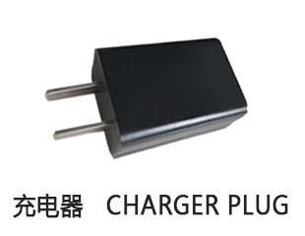 | 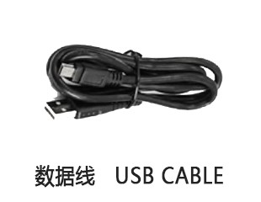
Universal Optional Accessories
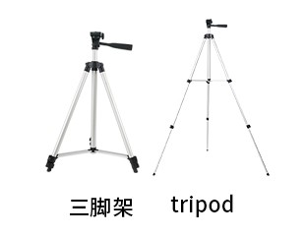 | 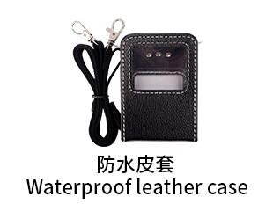 |  | 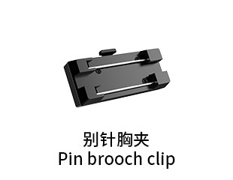 | 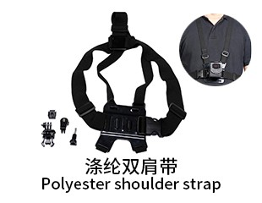
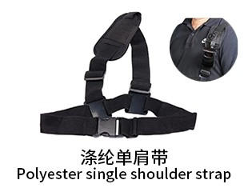 | 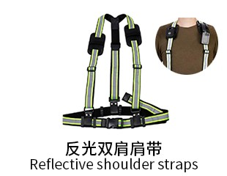 | 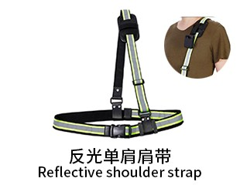 | 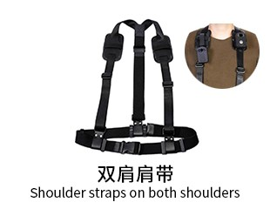 | 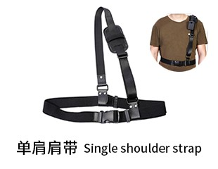
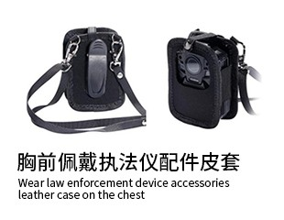 | 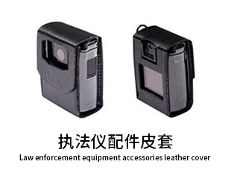 | 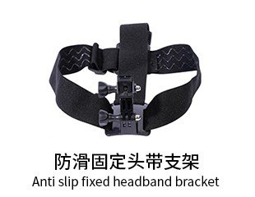 | 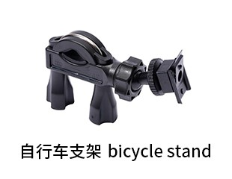 | 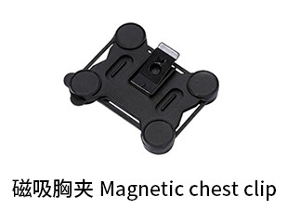
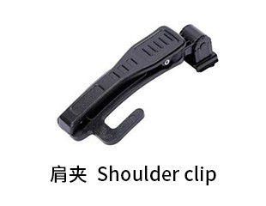 | 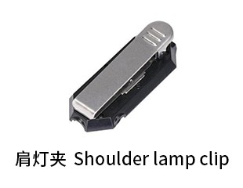 | 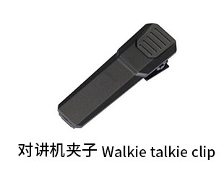 | 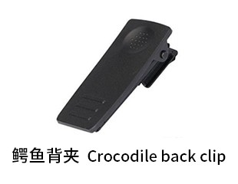 | 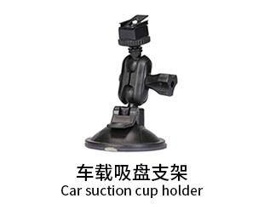
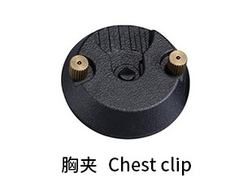 | 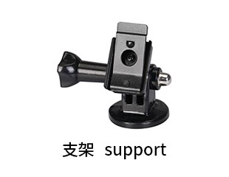 | 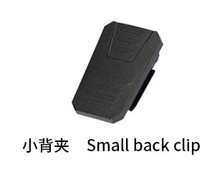 | 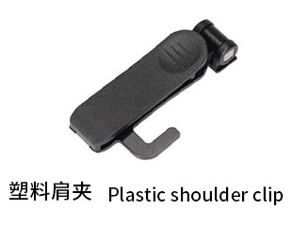 | 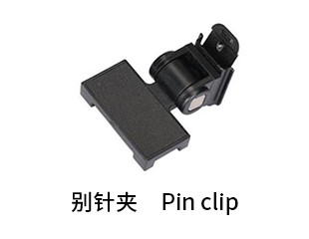
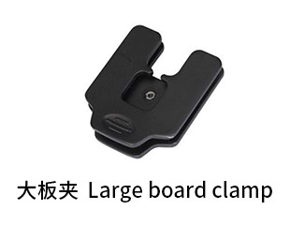 | 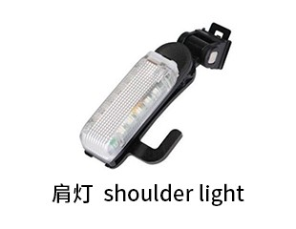 | 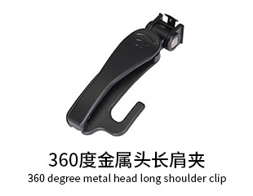 | 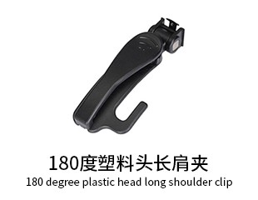 | 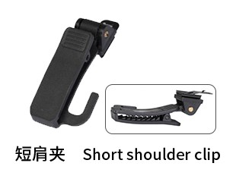
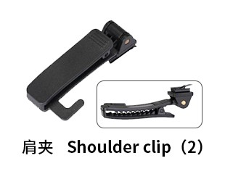 | 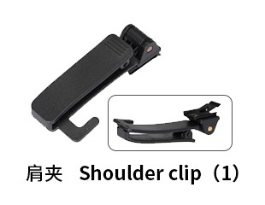 | 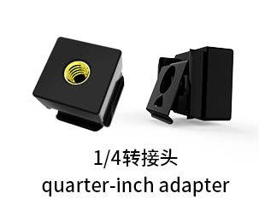
Generated At: 2026-08-21 00:44:17 | Specification Version: AWS-CAT1-4G Law Enforcement Recorder-Built-in Battery-851

